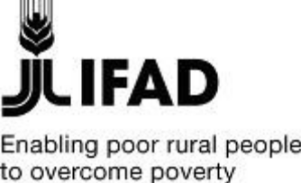

Republic of The Sudan

Integrated Carbon Sequestration Project

Terminal Evaluation Report

Final - April 2021

Table of Contents

Abbreviations and Acronyms 4
General Information 7
Executive Summary 9
1. Introduction 11
1.1 Purpose of the evaluation 11
1.2 Methodology 11
2. Project Description and Development Context 12
2.1 Project Start and Duration 12
2.2 National circumstances 12
2.3 Regional context 12
2.4 Problems to be solved by the project 13
2.5 The strategy to address the identified problems 14
2.6 Immediate and development objectives of the project 15
2.7 The reconstructed theory of change 15
2.8 Baseline Indicators established 18
2.9 Main stakeholders 20
3. Project Results 20
3.1 Strategic relevance 20
3.2 Achievement of outputs 21
3.3 Effectiveness / Overall outcomes and likelihood of impact 26
3.4 Efficiency 28
3.5 Sustainability 29
3.5.1 Environmental Sustainability 29
3.5.2 Financial Sustainability 32
3.5.3 Institutional Sustainability 32
3.5.4 Socio political sustainability 32
3.6 Progress to Impact 32
3.6.1 Immediate impact. 32
3.6.2 Long term impact 33
4. Assessment of Monitoring & Evaluation System 33
4.1 M&E design 33
4.2 M&E implementation 33
5. Assessment of Implementation and Execution 42
5.1 Quality of Implementation 42
5.2 Quality of execution 44
6. Other assessments 45
6.1 Need for follow-up 45
6.2 Materialization of co-financing 45
6.3 Environmental and social safeguards 45
6.4 Gender Concerns 45
6.5 Stakeholders Engagement 46
7. Lessons Learned and best practices 47
8. Partnerships 48
9. Recommendations 48
Bibliography 50
Annex 1. Terms of Reference of the Consultant 51
Annex 2 Georeferenced ICSP sites 52
Annex 3 List of persons met 57
Annex 4: Project Result Framework 58
Annex 5 Exit strategy plan, ICSP -30th July 2019 62

Tables
Table 1: Greenhouse Gas Source and Sink Categories 13
Table 2: Parameters used in the estimation of carbon stock 19
Table 3: Imagery Time Series of El Berega Forest, (ha) 25
Table 4: Environmental net benefits of ICSP (USD million) 31
Table 5: M&E. Physical progress of ICSP versus targets measured against indicators 35
Table 6: Summary of financial management risks and mitigating actions (at design) 43

Abbreviations and Acronyms

AF  AWPB  A/R  BD  BDA  BIRDP  CBS  CCU  CDM  DA  FAO  FM  FNC  FY  GEF  GHG  GIS  GoS  ICO  ICSP  IFAD  KM  LPG  LULUCF  MoAF  MoFEP  MoU  M&E  MTR  NCB  NRM  PCU  PIM  PM  PMU  PO  PP  PTA  QBS  QCBS  RAU  REDD+  RFP  RFQ  RIMS  RS  SBDs  SC  SCU  SDG  SM  SOE  SP  SUSTAIN  TC  TOR  UNDP  UNEP  VDCs  WA | Additional Funding  Annual Work-plan and Budget  Afforestation / Reforestation  Bidding Document  Butana Development Agency  Butana Integrated Rural Development Project  Central Bank of Sudan  Central Coordination Unit  Clean Development Mechanism  Designated Account  Finance and Administrative Officer  Finance Manager  Forestry National Corporation  Fiscal Year  Global Environmental Facility  Green House Gas  Geographic Information System  Government of Sudan  IFAD Country Office  Integrated Carbon Sequestration Project  International Fund for Agricultural Development  Knowledge Management  Liquefied Petroleum Gas  Land Use, Land Use Change and Forestry  Ministry of Agriculture and Forestry  Ministry of Finance and Economic Planning  Memorandum of Understanding  Monitoring and Evaluation  Mid Term Review  National Competitive Bidding  Natural Resources Management  Project Coordination Unit  Project Implementation Manual  Project Manager  Project Management Unit  Purchase Order  Procurement Plan  Policy and Technical Assistance  Quality Based Selection  Quality Cost Based Selection  Rural Administrative Unit  Reducing Emissions from Deforestation and forest Degradation and the role of conservation, sustainable management of forests and enhancement of forest carbon stocks in developing countries  Request for Proposal  Request for Quotation  Results and Impact Management System  Remote Sensing  Standard Bidding Documents  Steering Committee  State Coordination Units  Sudanese Pounds  Supervision Mission  Statement of Expenditure  Service Provider  Supporting Traditional Rainfed Small-Scale  Technical Committee  Terms of Reference  United Nations Development Programme  United Nations Environment Programme  Village Development Committees  Withdrawal Application

General Information

Summary project data
GEF project ID |  | 3915
GEF Agency project ID |  | Grant No. GEF-FSP-27-SD
GEF Replenishment Phase |  | GEF 4
Lead GEF Agency (include all for joint projects) |  | IFAD
Project name |  | Integrated Carbon Sequestration Project in Sudan
Country/Countries |  | Sudan
Region |  | Near East, North Africa, Europe and Central Asia Division (IFAD)
Focal area |  | Climate Change
Operational Program or Strategic Priorities/Objectives
Executing agencies involved |  | FNC
NGOs/CBOs involvement
Private sector involvement
CEO Endorsement (FSP) /Approval date (MSP) |  | 19 November 2012
Effectiveness date / project start |  | 11 December 2013
Expected date of project completion (at start) |  | 31 December 2017
Actual date of project completion |  | 30 September 2019
Project Financing
 |  | At Endorsement (US $M) | At Completion (US $M)
Project Preparation Grant | GEF funding | USD 100,000 | USD 99,685
Project Preparation Grant | Co-financing | USD 125,500 | USD 88,900
GEF Project Grant |  | USD 3,650,000 | USD 3,100,032
Co-financing | IFAD (BIRD-P) | USD 10,151,200 | USD 1,169,271
Co-financing | Government | USD 840,000 | USD 550,992
Co-financing | Forest National Corporation (FNC) | USD 67,800 | USD 16,708
Co-financing | Other multi- /bi-laterals
Co-financing | Private sector
Co-financing | NGOs/CSOs
Total GEF funding |  | USD 3,650,000 | USD 3,100,032
Total Co-financing |  | USD 11,059,000 | USD 1,736,971
Total project funding  (GEF grant(s) + co-financing) |  | USD 14,709,000 | USD 4,837,003
Terminal evaluation/review information
TE completion date |  | December 2019
TE submission date |  | April 2021
Author of TE |  | Youssef Brahimi, International Consultant for IFAD
TER completion date
TER prepared by
TER peer review by (if GEF EO review) |  | Fumiko Nakai, Senior Evaluation Officer, IOE, IFAD

Project boundaries

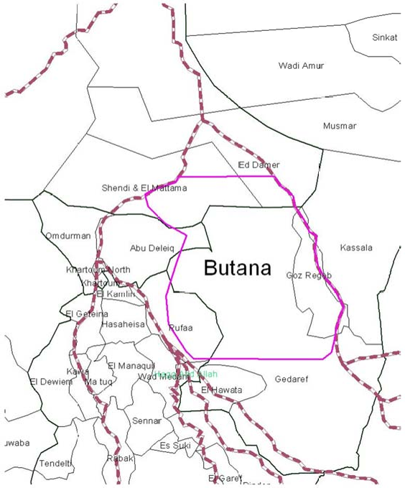

Executive Summary
The objective of the Terminal Evaluation is to provide a comprehensive and systematic account of the performance of the GEF-funded ICSP in line with IFAD and GEF-related reporting requirements. The evaluation was based on a participatory approach, which included three core elements: a) a desk review of relevant project documentation and other documents; b) interviews with key project participants and stakeholders; and c) a field visit to Gazira and Gedaref States.
The project was approved in November 2012 and the effective date of the project start was December 2013. The expected date of project completion was initially December 2017. However, due to delays in starting the project implementation, and in order to allow completion of project activities a nine-month no-cost extension of the ICSP was approved by IFAD in 2018. The project ended by 30 September 2019 with full financial closure by March 2020.
The ICSP has been designed to complement the Butana Integrated Rural Development Project (BIRDP). The goal of BIRDP is to improve in a sustainable manner the livelihoods and resilience to drought of the poor rural households. Therefore, the ICSP builds on BIRD intervention and aims towards addressing the gaps related to the forest and natural resources development including the high demand for biomass energy in the Butana area. The intended objectives are to contribute to the global incremental benefits of GHG mitigation while at the same time to enhance rural sustainable development in the project area.
The overall goal of sister ICSP project is to promote a climate-friendly rural development path in Central and Eastern Sudan by increasing the carbon stock and reducing net Green House Gas (GHG) emissions in the country, while at the same time sustaining rural development in the BIRDP project area. Therefore, the ICSP builds on BIRDP intervention and aims towards addressing the gaps related to the forest and natural resources development including the high demand for biomass energy in the Butana area. Its development objectives are to contribute to the global incremental benefits of GHG mitigation while at the same time to enhance rural sustainable development in the project area.
The baseline indicators have been established retrospectively, due to the delay in receiving co-financing from BIRDP, and are reflected in the logical framework. The estimation of the carbon stock in the baseline is the result of a study carried out in September 2019. The project managed to complete most of the planned activities under different components despite delays.
Below is a summary of the main achievements:
- Increase in tons of carbon stock in the project area reached 190,863 tons, which is higher than the target of 108,000 tons, attributed to the increase in areas of A/R from 10,000 ha to 14,911 ha
- Decrease of net GHGs emission in the project area based on the adoption of usage of alternative source of energy reached 56,149 tons, in line with the project target
- The project delivered its service to 14,612 persons out of which 10,394 are women and 4,218 are men
- The project enhanced the capacity of 782 technical staff and policy makers in bio-carbon issues against an initial target of 120
- The project intervention resulted in an increase in household assets for a total of 7709 HH, slightly short of the initial target of 9,000 HH.
The ratings of the project are summarized below.
Item | Rating
Relevance | S
Efficiency | MS
Effectiveness./ Overall outcomes | MS
Sustainability | ML
M&E Design | MS
M&E Implementation | MS
Quality of Project Implementation | MS
Quality of Project execution | S

These ratings take into consideration the country and local context, and the strong challenges facing the smallholder producers and rural women in Butana area.

1. Introduction

1.1 Purpose of the evaluation
This is the independent Terminal Evaluation (TE) of the International Fund for Agricultural Development/ Global Environment Facility (IFAD/GEF) Project on the Integrated Carbon Sequestration Project which is a project of the Government of Sudan. The evaluation was carried out by a sole evaluator with the support of the project team and IFAD.
According to the ToRs (Annex 1), the objectives of the TE are to: review and assess the performance of the ICSP fulfill GEF-related reporting requirements; provide a comprehensive and systematic account of the performance of the GEF-funded ICSP by assessing its design, implementation, and achievements of objectives; review all project documents and reports and collect all information deemed necessary to understand and analyze the project implementation achievements and failures, management and implementation capacities, structure and sustainability.

1.2 Methodology
The evaluation took place from 20 to 30 September 2019. The evaluation was based on a participatory approach, which included three core elements: a) a desk review: project documentation, IFAD supervision reports, BIRDP supervision reports, related national policies documents on Climate change and environment, and other relevant project documentation; b) interviews with key project participants and stakeholders. Several meetings were organized with the Project Coordinator and his team, as well as with the Forest National Corporation (FNC). The IFAD Country Programme and the GEF Focal Point were also interweaved; and c) field visit to selected sites: the field visit took place on the 25 and 26 September 2020. The visit was jointly organized at the federal level by the ICSP Management and the FNC, in collaboration with the representatives of the Gedaref State (Ministry of Agriculture and Forestry)
1: Visit of the Elmukharbash Forest (where A/R activities at Gedaref State has been established) with the FNC technical and protection staff together with the communities' representatives who has been involved in the establishment and protection of the forest.
2: Visit to Elhisania community where the evaluation consultant met the representatives of the 75 families who are benefited by the ICSP interventions (including the training and capacity building for planning, planting and adopting of agroforestry practices, the use and adoption of the biomass alternative energy sources for cooking and lighting). The discussions were facilitated by Abdalla Nasraldeen and Ezeldeen Mohamed (representatives of the community).
3: Visit to the representatives of the Elsoki Elsadgab (300 families) and Elsoki Elnorab (180 families), the meeting was facilitated by two members of these communities namely Mudathir Abdelrahman and Kamal Mohamed Taha who reflected on the benefits their communities have acquired from the interventions of the project both in terms of living standards and environmental protection, and the urgent need to scale up these interventions.
Because of security reasons, it was not possible to stay long enough on the sites, to visit all the sites and hold discussions with a larger number of stakeholders, even if the sites visited were representative of the main ICSP field activities.

2. Project Description and Development Context

2.1 Project Start and Duration
The project was approved in November 2012 and the effective date of the project start was December 2013. The expected date of project completion was initially December 2017. However, due to delays in starting the project implementation, and in order to allow completion of project activities a nine-month no-cost extension of the ICSP was approved by IFAD in 2018. The project ended by 30 September 2019 with full financial closure by March 2020.

2.2 National circumstances
At the time when the project was designed the contribution of forest resources to the Sudanese national economy was far underestimated (3.3% of the GDP) because estimates were based solely on the income from timber, didn’t consider the contribution to energy (more than 69% of the energy balance at present) and the value of other socio-economic and environmental benefits derived from forest resources. Forests contribute to the employment of around 15% of the labour force in rural areas. Gum Arabic produced by Hashab trees (Acacia Senegal) is an export commodity that earns foreign exchange and also supports the livelihoods of more than two million persons in the dry lands of Sudan.

2.3 Regional context
The project targeted the Butana region, an area lying between the River Atbara and the Blue Nile. The area falls under five States (River Nile, Khartoum, Gezira, Gedaref, and Kassala), and 10 localities (Sharg El Nil, Shendi, Shamal shendi, Kaboshiya, Eddamer, Es Soubagh, Um el Gura, Rufa’a, Satit, River Atbara). The Butana area is an extensive, monotonous flat plain. The northern areas are part of the desert/semi-desert zone and rainfall rarely exceeds 100 mm/year. In the central parts of Butana, which is part of the semi-desert, rainfall reaches 250 mm. Further south in the poor savannah, rainfall reaches 400 mm. The greater part of the Butana is, however, drained by numerous khors into inland deltas. Sorghum is cultivated in these deltas.
Butana occupies an estimated area of 81,497km² between latitude 14◦ 33’ and 16◦22’ north and longitude 33◦33’ and 35◦33’ east, in a rectangular shape surrounded by the river Atbara in the north-eastern part, the river Nile in the north-western part, the Blue Nile in the southwest, and the Kassala- Gedaref-Wadi Medani Road fin the East and South. Butana area is fragmented between five States, namely Gedaref (34% of the area), River Nile (28%), Kassala (15%), Khartoum (14%), and Gezira (9%).
The total population of Butana is estimated at 1 million inhabitants most of them are farmers and
nomads. The local economy is characterized by agro-industrial production driven by the installation of large irrigated and mechanized agricultural schemes and agro-processing industries as well as by increasing urbanization of main settlements on the riverine borders of Butana. Livelihoods, especially of the poorest, are hence a combination of subsistence production and migration in pursuit of wage labour.

The ICSP was designed to complement the Butana Integrated Rural Development Project (BIRDP). The goal of the BIRDP was to improve in a sustainable manner the livelihoods and resilience to drought of the poor rural households. Its specific objectives were the following: i) Establishing a coherent and cost effective governance framework that ensures a regulated access to land and water resources of the Butana; ii) Improving the access and bargaining position of women and men in the marketing of livestock; iii) Developing the capacity of community-based organizations to engage in environmentally sound, socially and gender equitable development initiatives.
The overall goal of sister ICSP project was to promote a climate-friendly rural development path in Central and Eastern Sudan by increasing carbon stocks and reducing net Green House Gas (GHG) emissions, while at the same time sustaining rural development in the BIRDP project area. Therefore, the ICSP built on BIRDP interventions to address gaps related to forest and natural resources development including the high demand for biomass energy in the Butana area. Its development objectives were to contribute to the global incremental benefits of GHG mitigation while at the same time to enhance rural sustainable development in the project area.
The project design report notes that BIRDP, while building the basis for a sustainable use of natural resources in Butana, did not take into account the potential of increasing the carbon stock in the project area and thus generate global environmental benefits.

Problems to be solved by the project
The main problem the project had to address was the steady reduction in the stocked volume of forest resources in Sudan, which has caused Sudan’s forest to become a source of GHG emissions rather than a net GHG sink. The root causes identified were: (i) the expansion of agriculture in the absence of proper land-use and forest management planning, (ii) increased urbanization, (iii) fuel wood production (firewood and charcoal, which constitutes more than 70% of total national energy consumption), (iv) and grazing.
Indeed, as reported in Sudan’s Initial National Communication (INC) to the United Nations Framework Convention on Climate Change (UNFCCC), agriculture and land-use, land-use change and forestry (LULUCF) are among the main emitters of greenhouse gases (GHGs) in Sudan. LULUCF generate net CO₂ emissions of about 15,577 Gg (corresponding to more than 75% of total CO₂ emitted). The Second Communication to UNFCCC summarized GHG emissions associated with LUCF in 2000. Relatively to overall anthropogenic GHG emissions, the 9,392Gg CO2e represents about 12% of total CO2e emissions.
Table 1: Greenhouse Gas Source and Sink Categories
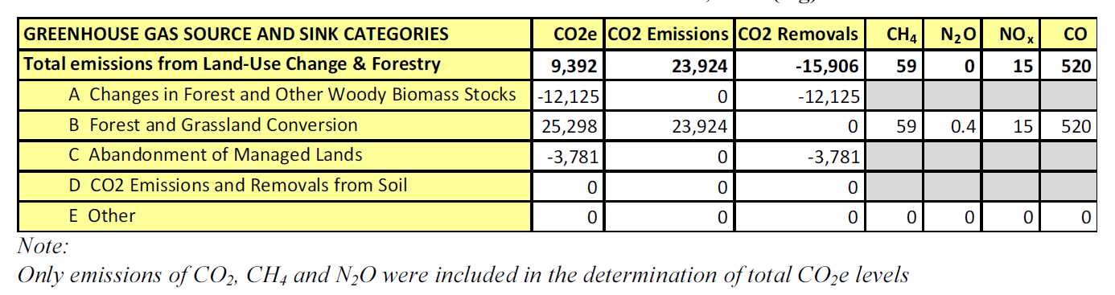
Since the ICSP was complementary to the BIRDP, the project has been implemented in the Butana Region, in which the Gedaref and Gazira States are States where large areas, including areas of forest and rangelands, have been negatively affected by mechanized agriculture. The expansion of mechanized agriculture in Gedaref state is estimated at 8 million feddan, taking into account the provision under the current Forest Law of allocating 10% of rainfed agricultural area to forestry, the land area available for A/R in Gedaref state can be estimated at 800,000 feddans (about 336,000 ha). They are the States where forest exploitation for wood consumption is mainly concentrated. More important, these States are characterized by the highest potential for biomass growth within Butana because of their location within an area of relatively high rainfall.

2.5 The strategy to address the identified problems
Therefore, the ICSP built on BIRDP intervention to address the gaps related to forest and natural resources development including the high demand for biomass energy in the Butana area.
The intended objectives were to contribute to the global incremental benefits of GHG mitigation while at the same time to enhance rural sustainable development in the project area.
This objective was pursued through the achievement of four key complementary outcomes:
- Afforestation and reforestation (A/R) activities successfully implemented through the increase of 10,000 ha of reforested area in sites with less than 40% of canopy cover, the development of agro-forestry initiatives involving landless farmers and the improvement of water harvesting systems to support successful A/R activities;
- Forest carbon stock is maintained in the long run, through the participatory forest management as a way to protect the carbon stock from drivers of deforestation (illegal felling, over grazing, poor management and forest fires), and the protection from causes of deforestation and fires through the development of Participatory Forest Management Plans (PFMP);
- Wide diffusion of highly efficient, biomass energy technologies (LPG, solar units, improved stoves) is promoted in the project area using climate-friendly incentives, developing awareness raising and capacity building actions;
- Institutional and technical capacities are developed for monitoring and reporting of forest carbon stock and changes at national level and awareness is raised at local level on forest and climate change mitigation. This will be reached by enhancing national capacity to develop implement and monitor potential LULUCF projects, as well as enhancing local capacity to promote forestry awareness among the target group, and to develop, implement and monitor potential LULUCF projects including CDM, REDD or voluntary mechanisms.
The ICSP was directly linked to the national implementation strategy for climate change in Sudan as described in Sudan’s Initial National Communication to the United Nations Framework Convention on Climate Change (UNFCCC), and was based on the mitigation options defined under both the energy and LULUCF sector in the INC. Also, the project was in line with the GEF-4 strategic objectives of (i) reducing GHG emissions from land-use, land-use change and forestry (LULUCF), and (ii) promoting sustainable biomass energy production. The focus of the intervention was on LULUCF activities and sustainable production and use of biomass energy.

2.6 Immediate and development objectives of the project
The Project Objective is to promote a climate-friendly rural development path in Central and Eastern Sudan by increasing the carbon stock and reducing net GHG emissions in the country, while at the same time sustaining rural development in the project area.
The Development Objectives are:
- To establish at least 10.000 ha of forests in areas with high potential for sustainable biomass growth using multiple A/R forms, mixed species and suitable water harvesting methods.
- To promote sustainable management and maintenance of biomass carbon stock through the implementation of standard forest management practices in selected forest reserves and A/R areas involving local communities.
- To promote wide diffusion of highly efficient, biomass energy technologies, as appropriate, in the project area using climate-friendly incentives.
- To develop technical and institutional capacities within FNC for GHGs mitigation, REDD+, forest and carbon stock monitoring and reporting, and access preferentially to the voluntary carbon market.
The ICSP comprised four technical components, aligned with the aforementioned development objectives and expected outcomes:

- Component 1: Increasing national carbon sequestration potential: This component focused on the implementation of A/R activities in suitable areas with favourable conditions for sustainable tree growth to ensure maximum carbon uptake. This component was executed with the participation of farmers, villagers, communities and the FNC.
- Component 2: Conservation and improved management of forest carbon stock: This component aimed at maintaining forest carbon stocks in the long run, through conservation and improved management including protection from fires and other causes of deforestation and.
- Component 3: Promotion of biomass energy technologies: This component focused on the promotion of wide diffusion of climate mitigation technologies for rural energy needs and was supposed to be funded by BIRDP.
- Component 4: Institutional and Technical Capacity: This component focused on building national capacity to develop, implement, monitor and report on carbon stock as well as raise awareness at local level on forest change and climate mitigation.

2.7 The reconstructed theory of change
No theory of change was developed at the design phase. The following problem tree and theory of change were developed based on the above presentation of key problems and proposed solutions, and with the contribution of the ICSP team.
The reconstructed theory of change considers the multiple interrelated factors contributing to forest degradation in the Butana region: pressure from the local population for scarce firewood resources and rangeland for their animals; additional exogenous pressures in the form of urbanization and expansion of agriculture in forest areas; aggravated by climate change. These pressures were insufficiently mitigated because of an inadequate natural resources governance framework, coupled with limited know-how, skills and material resources at the local level to monitor and manage forests. The resulting impact was a continuous process of land degradation, evidenced by a reduction in forest cover and carbon stocks, endangering the flow of environmental services for the population.
The project proposed to address this situation by focusing on key levers where, in line with IFAD’s mandate and comparative advantage, the most cost-effective outcomes could be achieved:

- Reforestation and afforestation, to rebuild the forest reserves, carbon stocks and strengthen the flow of environmental services that come from forests;
- Improving the capacity of local stakeholders to manage forest resources in the long term, ensuring that local populations become responsible protectors and stewards to secure for their communities the long-term benefits derived from well-managed forests;
- Reducing demand for firewood, through improved stoves, also generating co-benefits in terms of health and hygiene, particularly for women;
- Supporting the development of an enabling environment at national level.

Project actions were designed as an integrated package, in the geographical area also covered by the BIRDP project, to facilitate execution and ensure measurable and significant impact.
Figure 1: Problem Tree analysis and Theory of Change
Project objective
To promote a climate-friendly rural development path in Central and Eastern Sudan

Wide diffusion of highly efficient, biomass energy technologies, as appropriate, is promoted in the project area
Capacities for monitoring forest carbon stock and associated GHG fluxes are developed at the national level and awareness is raised at the local level about the role of forest and biomass carbon stock in climate Institutional and technical change mitigation
Proposed solutions/
Outcomes
Forest carbon stock is maintained in the long run
Increased national carbon sequestration potential
Poor capacity in Forests carbon stock management
Inadequate knowledge and technical capacity at local level in NR and forest M
Lack of alternative sources of energy/Poverty
Expansion of agriculture in Forest areas
Capacity building
Use of climate-friendly incentives
Conservation and improved management including protection from causes of deforestation and fires (A/R) activities
Land degradation and desertification
Absence of M&E system of Forest Carbon Stock
Overgrazing
Fuel wood production
Absence of proper land-use and forest management planning
Root
Causes

Afforestation and reforestation (A/R) activities

Problem statement
Sudan’s forest has become a source of GHG emissions rather than a net GHG sink

Deforestation

Increased urbanization

2.8 Baseline Indicators established
The core indicators, which are fully consistent with the logframe, were established for the start of the project through separate studies, and are reflected in the logframe (Annex 4) and the outcome measures (section 4.3). The estimation of the biomass and the carbon stock in the baseline is the result of retrospective studies carried out in September 2019.:
- The REDD+ baseline addresses the drivers of deforestation and forest degradation and establishing the Forest Reference Emissions Level. This study was implemented in selected forest to generate local data and parameters for better estimation of carbon stock change and GHG fluxes.
- The second study is related to Household Biomass Energy Consumption Alternatives & GHG Emission Reduction. Its objectives were:
  - To establish the baseline on biomass energy consumption in the targeted areas;
  - To assess enabling factors and barriers to wide diffusion of efficient energy technologies;
  - To provide recommendation on suitable strategies and incentives for Climate Change mitigation practices at community level;
  - To establish the baseline for a Clean Development Model (CDM) model whereby communities would be introduced to carbon market and have possibility to generate revenue (N/A).
The reason why these studies were retrospective studies is mainly due to the fact that the project did not received in time the necessary funding from the BIRDP project, as originally planned. In fact, IFAD's decision to grant an extension to the project saved the entire project by allowing these crucial studies to be carried out, and that provide the elements for a projection on quantity of biomass and carbon sequestrated at the horizon 2030. Indeed, as already indicated in the design document, the potential areas of A/R indicate that the removal of the baseline can be neglected (assumed to be zero) based on current CDM rules (either bare land or land with less than 2% crown cover). Therefore, the Afforestation/Reforestation (A/R) baseline study established the baseline for the A/R sites upon which the calculation of the changing of the biomass and carbon stock was measured, since the A/R activities were carried in totally bare areas (with 0% canopy cover). In this framework the base line set in the ToR of this study has been established based on the project log frame despite the delay in completing the baseline study. The inventory work carried in the A/R sites considered the fact of the 0% of canopy cover. The Afforestation/Reforestation (A/R) baseline study adopted a participatory and consultative process to develop the baseline for the project area, including: El Mukharbash, Liberator, Rahad agriculture scheme and Biraiga forest reserves.
The methodology for estimating the Carbon stock in the baseline was based on the identification of four distinct zones in the targeted forest area: the Talh newly planted zone, the agriculture zone, the Sunt seasonal streams zone and the Kitir zone. The estimation of the baseline carbon stock excluded the Talh zone containing the new plantation by the ICSP in years 2015-2017. The Talh zone represents the project case, which will be compared with baseline situation in future forest monitoring activities to verify whether the project is in track to achieving the climate change mitigation objective.
The formulas below used in the study are in line with the IPCC methodologies. They explain how the carbon stock in the baseline is estimated:
Total carbon stock in the baseline of the Liberator and El Mukharbash forest is equal to the summation of the carbon stock in the three identified zones, as follow:
C_{Baseline} = C_{Kitir} + C_{Sunt} + C_{Agric}
For water courses (Khors) and plantation/natural vegetation and zones following calculation methods apply:
C = B_{total} * CF
C: Carbon stock of trees in the targeted zone area, tons C
B_{total:} Total tree biomass in the targeted zone area, tons d. m.
CF: Carbon fraction of dry matter (default 4.7 or 0.5), t C (ton d.m.)-1
B_{total} = V_{AG} * D * (1+R)
V_{AG:} Total aboveground volume of the tree in the targeted zone area
D: Basic wood density of tree species, tons d.m. m³
R: Root-shoot ratio for tree species, dimensionless
V_{AG}: V_{ha} * A
V_{ha:} Total aboveground volume per ha, m³/ha
A: Area of the targeted zone, ha
In the bare land (where agriculture practiced) carbon stock is assumed to be equal to zero since all trees have been cleared and continue to be cleared every year when farmers do land preparation of the new cultivation season.
The parameters used in the estimation of carbon stock in the baseline of the El Mukharbash forest presented in the table bellow
Table 2: Parameters used in the estimation of carbon stock
Parameters | Value
Wood density Sunt | 0.7 - 0.8  t.d.m. m3
Wood density Kitir | 0.7  t.d.m. m3
Root/shoot ratio Sunt | 0.84
Root/shoot ratio Kitir | 0.53
Total volume of trees/ha Sunt | 1.25 m3/ha
Total volume of trees/ha Sunt | 1.42 m3/ha
Wood density Talh | 0.7 – 0.75
Root/shoot ratio Talh | 0.47

The study on Household Biomass Energy Consumption Alternatives & GHG Emission Reduction showed that, for the Baseline information for biomass energy consumption in the targeted areas, the main source of income was secured from agricultural activities, as there were no activities in relation to wood, non-wood and other commercial production and marketing activities. About 96.8% of villages had no wood or charcoal yards. In addition, people were not involved in the activity of converting firewood to charcoal. Regarding the fuel wood consumption, there was a great dependence of Albutana’s population on biomass-based fuels, in particular the fire wood, and ineffective technologies, for example old-fashioned stoves have placed excessive pressure on forest resource in the area.
Total biomass Consumption (ton wood fuel) /year is estimated 689,675.2, Co2 Emission associated with total consumption tco2/year was estimated 885,083.2 tons.

2.9 Main stakeholders
The main stakeholders identified in the ICSP Design Report include:
- The Ministry of the Environment, for its mandate as a policy maker and potential to play a coordinating role;
- FNC, for having a large experience in the forestry sector (A/R and biomass energy saving), making it apt to be closely involved in the management of the project;
- MFC, for its great interest in combat of deforestation
- Community organisations (including BIRDP related institutions, such as credit and savings associations/sanduqs, village development committees and community/producer organisations for forest management plan development etc.), for having interest in poverty reduction and improved livelihoods, and having direct access to local communities;
- Local government, for being responsible for local development.
The communities involved in the project comprise: a) Farmers and owners of rain-fed agricultural schemes participating in the A/R activities in the rain-fed area. The total targeted area has been divided in accordance with the provision of the Forest Act/policy that call for the allocation of 10% of rain-fed area to forestry land use; b) Land less people involved in agroforestry in irrigated area. As per design the agroforestry activities were carried out in reserved forest through special agreement between FNC and Landless people to ensure that landless will directly benefit from their involvement; c) Community forests; villagers involved in establishment of village woodlots, women forests and other community forests on communal land. All categories include rural women and youth.

3. Project Results

3.1 Strategic relevance
Relevance. Were the project outcomes congruent with the GEF focal areas/operational program strategies, country priorities, and mandates of the Agencies? Was the project design appropriate for delivering the expected outcomes? | Rating : S

The project design and its results framework was fully relevant to the GEF focal area on Climate Change as well as national priorities. Indeed, the Intended Nationally Determined Contributions (INDCs) of the Republic of Sudan presents Sudan's Intended mitigation contributions according to the different economic sectors. The ICSP was conceived to contribute directly to the achievement of the objectives for the forestry sector by: 1) contributing to the National Afforestation and Reforestation programme (Afforestation/reforestation supports climate mitigation (emission reduction - carbon sequestration by increasing the forest cover in the country); 2) contributing to the implementation of the National REDD+ strategy (Reducing emissions from deforestation and forest degradation and enhance carbon sequestration and livelihoods). ICSP also contributed to the objective of the IFAD country strategy to improve the livelihoods of poor farmers through sustainable natural resource management. In addition, and despite the delays in the implementation of the project, the findings of the ICSP were relevant to ongoing REDD+ readiness process.

3.2 Achievement of outputs
The lack of progress during the first two years of the project disadvantaged the project in terms of overall project performance. However, despite this handicap, most outputs reached a satisfactory level of accomplishment.
Output: 1.1. 10,000 ha of reforested area in sites with less than 40% of canopy cover
Indicators:
2.1.1 # of community forests registered and managed by local communities in a participatory manner
2.1.2 # of community and home nurseries established
2.1.3 # of seedlings produced
- The total number of ha reforested reached 14,911.2 ha (149% of the initial target) within three main sites:
- Reserved forests total of 12,751.2 ha; the appraisal target was 5,000 ha which, based on the site selection, modified to be 7,098 ha
- In shelterbelt and community forests 1417 ha were implemented, out of appraisal target of 4,000 ha, which also changed, based on site selection study, to 2,090.3 ha;
- In irrigated sites a total of 743 ha planted out of appraisal target of 1000 ha which was modified, based on site selection study, to 886.94 ha;
- The implementation of A/R activities resulted in increasing of carbon uptake to 190,863 tCO₂ which represent 177% of the initial set target;
- For the project to implement the A/R activities and the afforestation at household’s level rehabilitation of two central nurseries was accomplished;
- The Monitoring system is in place.
This output was at the core of the project. The results achieved are impressive, given the delays accumulated during the first years of the project. It is worth noting that the evaluation of increasing of carbon uptake (190,863 tCO2) is based on the findings of the study “Developing Baseline for the afforestation & Reforestation (A/R) in the Project Area: Gadaref and Gazira States (September 2019).

Output: 1.2. Agroforestry initiative involving landless farmers implemented
Indicators:
1.2.1.1 # of land less communities involved in agro-forestry activities
1.2.1.2 Area under agroforestry
The total area under agroforestry reached 743 ha out of initial target of 886.94 ha. Under this output 975 landless HH have become involved in agroforestry activities compared to a target of 1,000 HH. The ICSP Progress Report of 30 September 2019 noted that participatory approaches for implementing A/R activities in the community forests in Gezira proved to be one of the ICSP success stories featuring the positive involvement of local communities in agroforestry activities, in particular women.
Output 1.3: Improved water harvesting systems are defined and implemented to support successful A/R activities
Indicators:
1.3.1 Area with water harvesting systems (ha)
1.3.3 # of water harvesting micro catchments constructed
Water harvesting systems implemented assist the successes of seedling by improving the fertility of soil and enhance water retention as 1,042 ha being under water harvesting with total water harvesting micro catchments of 650 ha, corresponding to 297 Km of trenches/bunds constructed. FNC provided tractors and Delfino ploughs to adopt the most successful water harvesting techniques to capture rains and runoff water. This is expected to increase the survival rate up to 85%, according to studies carried out by the FNC for the Butana area. It is noted that the project cancelled the activities included in the Project design concerning the construction of hafirs (reservoirs) and digging wells.
Output 2.1. Participatory forest management
Indicators:
2.1.1 # of community forests registered and managed by local communities in a participatory manner
2.1.2 # of community and home nurseries established
2.1.3 # of seedlings produced
So as to involve local communities in project activities, in particular agroforestry, the project established 48 home nurseries out of the 21 home nurseries planned (228% of the target). They contributed in the production of 48,000 seedlings. Most of these nurseries are managed by women.
Output: 2.2: Fire management system is improved and post fire management plans are developed and implemented
Indicators:
2.2.1 Fire Risk Management Plan elaborated
2.2.2 # of fire lines opened
The activity concerning the establishment of Fire brigades was cancelled. The project concentrated its efforts on the elaboration of a Participatory Forest Management Plan (PFMP) including the Fire Risk Management Plan, as well as the opening of 312 km of fire lines (out of 360 km targeted).
The PFMP aims to guarantee the sustainability of biomass carbon stock as follows:
- Recognized and encouraged the establishment and ownership of community, private and institutional forests,
- Stressed the role of people participation in forest plantation, management and protection,
- Conceptualized the multiple uses of forests,
- Encouraged local populations to participate in preparation of forestry & environmental projects and their implementation,
Output 2.3 Long-term sustainability of biomass carbon storage potential increased

Indicators:
2.3.1 Increase in carbon stock
2.3.2 Area of forest reserves increased
Sustaining forest resources remains promising with the communities as stewards for public resources and goods. Community involvement is key to the development of Participatory Forest Management Plans.
The area of forest reserves increase achieved 179% of the target (12,751.2 ha out of 7,098 ha initially planned). The studies of A/R baseline and PMFP stated that the increase of carbon stock in the project area is 107,000 tCO₂ which means that within the project impact period (15 years from end up) will reach in forest area 1,535,739 tCO2.

Output 3.1. GHG emission from biomass energy production
Indicator:
3.1.1 Level of reduction of biomass energy use
The level of reduction of biomass energy use has been evaluated to 206,902 Ton/year (100% of the target). To reduce the emission from the use of biomass as source of energy, 1,746 LPGs unit, 3,672 improved stoves and 2,626 solar units were distributed through revolving funds mechanism to 7,709 HH.
Percentage of reduction of fuel wood consumption upon adopting renewable /efficient energy was evaluated to 35%. The diffusion of efficient and shifting energy targeting a total of 1746 LPGs & 3,672 improved stoves has lead to an emission reduction to about 14,105 tco2e/year and savings of about USD 437,89. Total Emission reduction tco2 by the end of the project (4yrs) was estimated to about 56,419 tco2e and savings of USD 394,934, expected to reach USD 1,481,004 over 15 years.
Based on the study of HH biomass consumption, total consumption of biomass in the project area is 689,675 annually. The key findings of the baseline information for biomass energy consumption in the targeted areas showed that the main source of income is secured from agricultural activities, as specified by about 41.7%, whereas there are no income-generating activities in relation to wood, non-wood and other commercial production and marketing activities. About 96.8% of villages have no wood or charcoal yards, except only one in Aledid Atowal village in Algadarif, and none in Gezira. In addition, people are not involved in the activity of converting firewood to charcoal, as indicated by 99.2%. Regarding the fuel wood consumption, there is a great dependence of Butana population on biomass-based fuels, in particular firewood, and ineffective technologies. For example, traditional “three stone” stoves have placed excessive pressure on forest resource in the area. The majority of Albutana people depend on the 3 stone stoves fire, as indicated by 88.6%, charcoal stove 82.3%, LPGs stove 56.3%, electrical heater, 6.3%, improved stoves 5.9%, wood stoves and others 1.6%, while the agricultural residues obtained the least value 0.8% and there is no usage of kerosene in the area. As well it revealed that most of Albutana households use charcoal by (61.8%), LPG by (61.4%), firewood (54.7%) as a source of energy.
Output 3.2. The use of improved and modern stoves
Indicators:
3.2.1 # of improved and modern climate friendly stoves used in the project area (2,000 LPG).
3.2.2 # of households using improved wood stoves (3,672)
Based on the findings of the study on the assessment of Alternative Energy Needs for ICSP communities, the recommended types and number of efficient energy units for each village was based on the number of HH in each income group. Distribution of solar lanterns, on the other hand, was recommended for HH who have no electricity connections. Distribution was done with the same revolving fund system adopted by BIRDP. Each HH women pay monthly installment for all received efficient units, as determined by ICSP staff and women development organization members in the village. 1,746 LPG units and 3,672 improved stove units were distributed by the project.
Visits on the field showed the population's heightened interest for accessing to LPG stoves, solar energy units or improved stoves. Population commitment to protect the forest is directly linked to the possibility to use other sources of energy than wood (LPG, solar energy) or to reduce use of wood (improved stoves). Based on BIRDP experience, the project put in place revolving funds to support the dissemination of LPG cooking facilities. In terms of sustainability, the local communities are part of the process, particularly in the identification of beneficiaries, and FNC representatives at State/Local level committed to continue the process after the end of the project. The interests of providing loans for access to GPL rather than grants are justified by the population commitments as well as the possibility of sustaining the process after the end of the project.
Output 4.1 Enhancing national capacity to develop implement and monitor potential LULUCF projects including CDM, REDD or voluntary mechanisms
Indicators:
4.1.1 # of baseline surveys and data collected on deforestation and forest degradation
4.1.2 # of analyzed and processed relevant time series data for monitoring land use change and carbon fluxes and stocks;
4.1.3 # of technicians trained in GIS
4.1.4 # of training and awareness raising events
4.1.5 # of studies to generate data for better estimation of carbon stock changes and fluxes
4.1.6 # of MRV models established for carbon stock change and fluxes
4.1.7 GIS tested for LULUC monitoring
Elberaga reserve forests was selected as a model forest for REDD+ and developing MRV system and identify the drivers of deforestation and degradation in the project area and to establish base line for ERL & FERL. The local communities confirmed that the project areas witnessed a continued change in the forest cover and land-use. The following tables show the imagery time series and land use changes that have taken place during the period 1984-2017 in the three areas, (El Berega Forest).
The following table shows the Imagery Time Series of El Berega Forest, (ha).
Table 3: Imagery Time Series of El Berega Forest, (ha)
Imagery time series | Forest | crop land | settlement | Deforestation  Averg/year | Total
1984 | 4955.95 | 440.68 |  |  | 5396.63
2006 | 4898.04 | 498.59 |  | 2.6 | 5396.63
2009 | 4867.58 | 516.65 | 12.40 | 10.2 | 5396.63
2013 | 4870.38 | 518.95 | 7.30 | 0.7 | 5396.63
2017 | 4813.22 | 572.27 | 11.14 | 14.3 | 5396.63
Deforestation average/year (1984 - 2017) |  |  |  | 6.6 ha/yr

It must be highlighted that this forest is not part of Project A/R implementation side, however this forest has been selected to reflect the rate of forest degradation and deforestation by the existing drivers: this why the project as part of its activities has developed a model FMPP to be adopted in the reserved forest in the area as part of it is Exit Strategy.
The project conducted capacity building training in GIS and remote sensing to enhance monitoring of LULUCF for 116 technicians.
The project hired an international consultant to develop road map to MRV system. Here below is a summary of activities planned and/or achieved as at end of 2019.
Activity | Description and progress as of March 2019 (according to FAO, 2016; FAO, 2018; FAO, 2019a)
1.1. Support to MRV Tech. WG (TWG) | The MRV TWG receives the technical support of FAO, so as to be deeply involved in the decisions regarding the NFMS action plan. During the mission, it proved difficult to identify roles/responsibilities of this MRV TWG in the decision-making process regarding the NFMS
1.2. Assessment of MRV gaps, arrangements, roles and responsibilities | The first assessment of the MRV gaps and institutional arrangement has been conducted and is available (Roberts & Osman, 2017). To further deepen and verify the feasibility of the recommendations, a consultation process was initiated at national level and all potential implementation institutions (at national and subnational level) were invited to further discuss about the management of the NFMS system in Sudan and their involvement.  On the basis of these consultations, the Government is to develop the legal text for the institutionalization of their mandate in the framework of REDD+ and MRV.  The creation of a Data Management Unit (DMU), in charge of the implementation of the NFMS is planned within FNC, as well as capacity building of its members (see activity 1.5.).
1.3. Data management needs are assessed and equipment are procured | FAO experts, with the support of a national information technology / database expert visited FNC premises and assessed existing equipment used for field data collection/computing, and developed a procurement plan (purchase, installation and servicing over the project's period). Most of the equipment has already been purchased (Salah, 2018).
1.4. Design & implementation of a NFMS/MRV action plan | The timeline for the implementation of the NFMS/MRV action has been updated, taking into consideration the delays in implementing the NFI, the LULUCF mapping, and the GHG inventory.
1.5. Strengthening of NFMS/Data Management Unit (DMU) | The creation of a NFMS/DMU is planned, as explained earlier (see activity 1.2). It is supposed to receive operational and technical support from FAO (centralization of all trainings provided from FAO: in NFI, in remote-sensing, in GHG inventory and in web portal development and update). The creation of an office space is planned for this DMU, which will be in charge of the management of all data for the implementation of NFMS and MRV system. This unit will also be responsible of the update of the REDD+ web geoportal.  FAO intended to intensify MRV-works/trainings at State level, but decision by FNC of the selection of the focus States is still pending.  An international MRV expert was to be hired to coordinate MRV activities, ensuring the consistency of overall technical support from FAO, strengthening the DMU capacity. However, this was postponed due to continued volatile security situation in the country

The continuity of the above planned activities is ensured by FNC on its own budget, as per the exit strategy of the ICSP, as FNC is the REDD+ Focal Point and the ICSP implementing entity as well. Within its mandate, the project achieved its objective which was to develop a MRV road map to be executed by FNC.
Output 4.2 Enhancing local capacity to promote forestry awareness
Indicators:
4.2.1 #. of training sessions in awareness raising campaigns for communities and policy makers
4.2.2 # of participants in training and awareness events
4.2.3 # of pilot projects on non-wood forest products
Under this output two training sessions and awareness raising campaigns for communities and decision makers were conducted (out of 4 targeted). More than 36 internal and external trainings were conducted for 782 participants from the related partners and communities. Pilot projects were not implemented.
Output 5.1 FNC and BIRDP implement programmes and financial management systems that meet IFAD requirements
Indicators:
5.1.1 Project implementation on schedule
5.1.2 Website accessible
The project was not implemented on schedule due to the late start of the project. However, the project delivered a significant share of the planned outputs, leading to measurable outcomes. The website is functional but remains internal to FNC staff.

3.3 Effectiveness / Overall outcomes and likelihood of impact
Effectiveness. To what extent were the project’s actual outcomes commensurate with the expected outcomes? | Rating : MS

Most of the outcomes have been achieved, despite the initial delay.
Outcome: 1. Afforestation and reforestation (A/R) activities successfully implemented and lead to increased national carbon sequestration potential
Indicators:
1.1.1.# of ha of afforestation in sites with less than 40% canopy cover
1.1.2 # of communities/households participating in increasing national carbon sequestration potential through A/R
1.1.3 Baseline on A/R assessed
The project succeeded in implementation of A/R activities in sites with less than 40% canopy cover in reserved forests, shelterbelts, communities’ forests and irrigated sites that cover 14,911 ha in total compared to a target of 10,000 ha.
Local communities at household level and farmers participated actively in increasing national carbon sequestration stock potential through A/R activities as 8,684 persons participated in the implementation of A/R activities out of a target of 10,000 person.
The implementation of project activities is controlled and measured against the A/R base line study conducted by Agro –consultant firm.
Outcome 2: Forest carbon stock is maintained in the long run, through conservation and improved management including protection from causes of deforestation and fire
Indicators:
2.1. carbon stock\ tons\ha
2.2 stakeholders involved in maintaining forest carbon stock in the long run.
The Participatory Forests Management Plan (PFMP) are part of the project exit strategy for the sustainable protection of carbon stock which is, up to the end of project, of 190,863 tCO₂. The study has been carried out with the involvement of local communities so as to involve them in the long run maintenance of carbon stock. It is worth noting that FNC, the ICSP implementer, consider this project as a pilot project feeding the future actions foreseen during the REDD+ implementation phase. In this spirit, the PFMP is considered as a relevant tool to be replicated in the future, through REDD+ activities.
Outcome 3. Wide diffusion of highly efficient, biomass energy technologies, as appropriate, is promoted in the project area using climate-friendly incentives
Indicators:
3.1 use of LPG in 2,000 households
3.2 use of improved wood stoves in 7,000 households
Regarding the use of LPG, the initial appraisal was 2,000 households. In light of the findings of the study on alternative energy assessment, a reduced target was pursued and achieved: 1,746 households adopted LPG units, instead of the 2,000 originally foreseen. Regarding the use of improved wood stoves, the initial appraisal was 7,000 households. Based on the study’s recommendations a reduced target was pursued and achieved: 3,672 households adopted the use of wood stoves, instead of the 7,000 originally foreseen.
The project achieved 1,746 LPGs unit, 3,672 improved stoves and 2,626 solar units distributed through revolving funds mechanism to 7,709 HH so as to reduce the emission from the use of biomass as source of energy.
Outcome 4. Institutional and technical capacities are developed for monitoring and reporting of forest carbon stock and changes at national level and awareness is raised at local level on forest and climate change mitigation.
Indicator:
4.1 Monitoring system for measurement of carbon stock and associated carbon fluxes in place and fully operational, including baseline
At this stage the Participatory Forest Management Plan (PFMP) has been established. The PFMP 2020-2035, achieved in June 2019, documented and analyzed the current forest reserve situation including the assessment of the baseline (existing resource including wood and carbon stock and surrounded socio economic aspects). The plan prescribed a set of programmes to address the forest rehabilitation, conservation and protection, taking into account important issues such as gender, local people rights and privileges, legal forest management agreement, cost/benefits sharing to improve the effectiveness and efficiency of the management of the forest. However, at the date of the evaluation, the PFMP had just been approved and was not yet implemented. Notwithstanding trainings on GIS and Remote Sensing that the project provided in March 2019 to 47 participants, including Technical Officers and Project Managers from FNC, the GIS system was not in place at the date of the evaluation (all the work is done using Excel sheets). Thus, some M&E elements were in place but the M&E system was not yet fully in place and functional.
Outcome 5. Successful implementation of project achieving agreed objectives (Project Management).
Indicator:
  - Project implementation on schedule (% of implementation)
The project was not implemented on schedule, due to the late start of the project.
This indicator was not well aligned to the outcome, as it is more linked to the evaluation of the project management and timeliness than overall achievement of agreed objectives of project activities on the field.
The overall rating on Effectiveness (of project outcomes) is Moderately Satisfactory (MS).

3.4 Efficiency
Efficiency: Was the project cost-effective? How does the project cost/time versus output/outcomes equation compare to that of similar projects? | Rating MS

The two-year delay in project start-up affected the project efficiency appraisal. At the administrative level the project suffered of lack of qualified human resources and the absence of coordination with the BIRDP, which was supposed to support some ICSP activities financially and technically. However, the PMU staff demonstrated a strong commitment to overcome the delays, even if some weaknesses persisted in terms of planning activities. In addition, the project faced dramatic changes in exchange rate which affected implementation of planned activities and reporting on financial performance and objectives achievement.
At the economic level the project has exceeded its objectives in terms of quantity of carbon sequestered (190,863 tons out of 108,000 tons targeted). The decrease of net GHG emissions in the project area is equivalent of what was targeted, i.e. 56,149 tons. This implies a carbon cost of 12,55 USD/ton, which compares favourably with the carbon price of 20 USD/ton estimated by the Earth Innovation Institute to be an adequate threshold to substantially incentivize reforestation in 21 countries (17 of which are in Africa). At the local level, the strong community involvement in the different project initiatives, on agroforestry, use of non-wood energy sources, capacity building activities and trainings, further constitute significant gains from a local development perspective.
If the socioeconomic conditions allow sustainability of the activities, and if one considers the long-term projection of carbon stocks (horizon 2035), then the cost of stored carbon will be further reduced. Given the important social co-benefits that are a strong guarantee of sustainability, this can be considered a highly cost-efficient operation.

3.5 Sustainability
Sustainability | Rating: Moderately likely
Sustainability will be evaluated through different criteria: the environmental sustainability, the financial sustainability, the institutional sustainability and the socio-political sustainability.

3.5.1 Environmental Sustainability
The project has developed a participatory Forest Management Plan (PFMP) that will be implemented by FNC and other relevant stakeholders to ensure the Environmental sustainability (ES) beyond project life. Also, the capacity building and training program delivered to local communities in the fields of the management of natural resources and the adoption of the use of alternative energy sources is an integral part of the ES of the project. In this framework one can acknowledge that ICSP played a pilot role for NFC. This institution tested innovative approaches and drew lessons for the future implementation of REDD+. The PMFP approach is one of the tools which will be used for future interventions of NFC in other regions.
In addition, the environmental net benefits of the ICSP have been calculated on the occasion of the BIRDP supervision mission. In this study the computation of environmental benefits starting in 2015 (year 7 of the BIRDP) is based on three elements:
- Afforestation for carbon Sequestration (in tons): the number of hectares of forests varied from 260 in 2015 to 1093 in year 20 of ICSP with an average price of 28 USD of carbon sequestrated per year. The total value of carbon goes from USD 93 816 in 2015 to USD 394 462 in 2020;
- The reduction of greenhouse gas (GHG) emissions by: i) the distribution of 5418 LPGs and improved stoves of households per year with an annual increase of 30 units each year starting from 2015 to 2028. The price per unit considered in the analysis is 73 US$/unit. In parallel, the use of solar units contributes to the reduction of GHG emissions. This will reduce emissions to about 14 105 tco2e/year and a revenue about USD 98 734;
- The practice of agroforestry by combining at the farm level agricultural and forestry to create productive and sustainable land use practices. The ICSP aimed at planting 100 ha per year, starting year 2015 with a net revenue of USD 93.37 per ha.
The table below presents the detail of calculations. It is however important to note that the forecast is based on best available estimates provided by the project team and validated by the IFAD Supervision Mission in September 2019. An analysis of the robustness of the assumptions and sensitivity of the outcomes to changing conditions was not performed.

Table 4: Environmental net benefits of ICSP (USD million)
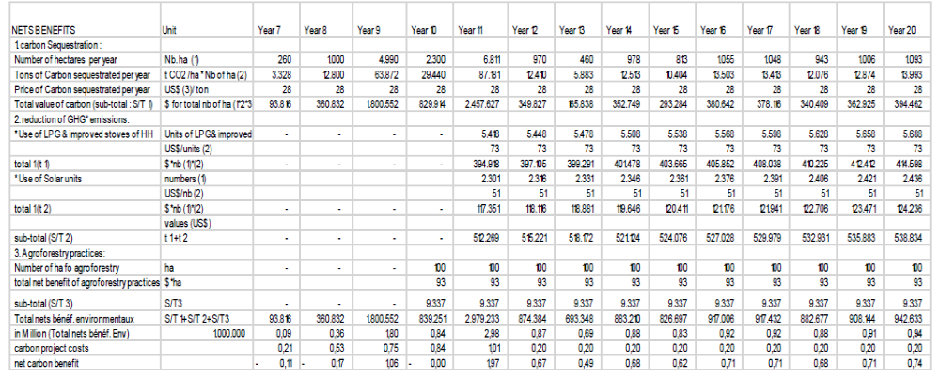
Source: IFAD supervision mission of BIRD project, September 2019

3.5.2 Financial Sustainability
As this project is implemented by Forests National Corporation (FNC), under the umbrella of the Ministry of Finance, FNC will continue supporting the sustainability of the outcomes of the project with full coordination and collaboration with related partners. In addition, ICSP activities are mainstreamed into FNC programming, and FNC, as the focal point of REDD+ program, will continue seeking governmental support at different levels through REDD+ funding mechanism. REDD+ is a global mechanism to mitigate the climate change caused by forest loss or degradation, while mobilizing financial resources for socio-economic development in forest countries. The Forest Carbon Partnership Facility (FCPF) supports Sudan in the preparation and implementation its national REDD+ strategy. The main activities of Sudan Readiness-Preparation Proposal (R-PP) are;
- Support the management arrangement, information sharing, stakeholders’ consultation and participation.
- Preparation of the REDD+ strategy including social and environmental assessment.
- Some aspect of national forest monitoring.
Before the end of 2020 the REDD+ Sudan will have started the processes of design and formulation of pilot emission reduction programs targeting three hot spot areas (highly degraded deforested areas e.g. areas affected by mechanized farming, areas of high demand of energy of biomass and Gum Arabic belt funded by GCF. After that full implementation phase will be started where large scale program will be developed.

3.5.3 Institutional Sustainability
Based on the project Exit Strategy (ES) all partners are committed to continue in playing their roles in supporting the sustainability of the project outcomes to reach the desired environmental impact, by enforcement of the existing legislation and incorporating environmental and climate change adaptation and mitigation issues in the governmental strategic policies and legislation. The Participatory Forests Management Plans (PFMP) have shown to be an effective mechanism for the involvement of local communities to mainstream them in the maintenance of carbon stock. It is worth noting that FNC, the ICSP implementer, consider this project as a pilot project feeding the future actions foreseen during the REDD+ implementation phase.

3.5.4 Socio political sustainability
The project introduced innovative interventions in carbon management in Sudan that support the enhancement of the quality of the life of farmers and rural communities. The combination of A/R activities together with agroforestry and facilitating access to new energy sources (LPG, solar units, improve stoves) directly and positively impacted the quality of life of poor farmers and land less farmers. Awareness activities and trainings gave them the capacity to improve their livelihood while understanding the importance of protecting the forests.

3.6 Progress to Impact

3.6.1 Immediate impact.
The immediate impact of the project is tangible. With regard to environment around 15,000 ha of forest has been planted, resulting in an increase of 190,863 tons of carbon stock. The actions of the project led also to a decrease of 56,149 tons of net GHG emissions in the project area. With regard to improving livelihoods, 4,218 men and 10,394 women received project services. 7,709 families saw an increase in their household asset base.

3.6.2 Long term impact
It is too early to assess the long-term impacts of the project since its completion date was the 30 September 2019. However, the involvement of local communities and local NGOs in the project design and implementation, their strong commitment to protect natural resources and forests because of the alternative energy resources they can now access and because of their awareness of the crucial importance of sustainable natural resource management, are encouraging factors to ensure long-term impact. At the institutional level FNC has fully integrated the results of ICSP in the implementation of REDD+, which is also a guarantee that ICSP can have long-term impacts, in synergy with the other actions planned by REDD+.

4. Assessment of Monitoring & Evaluation System

4.1 M&E design
M&E Design | Rating: MS

The M&E design adequately structured the main components of the Monitoring and Evaluation system implemented by the project:1) The Management Information System (MIS) which was built to generate quantitative verifiable information to feed 3 levels of decision making: the CSP, the State Circle Coordination and the Community Organizations; 2) For the M&E Arrangement and Organization, the organization of M&E for ICSP was conceived to correspond with the 3 M&E levels of the BIRD: CSP, FNC Circles and the Community Organizations. In view of highlighting the importance of M&E it was proposed that the M&E Officer also cumulate with her/his function the responsibility of deputy director, with the responsibility for: the aggregation of the physical and financial data from the FNC Circle; verification of this data; analyzing and reporting on trends in performance, gaps and successful results; negotiating corrective or enhancing measures with the Director of the CSP for endorsement; formulating the annual work plans and budgets of the project accordingly; organizing the baseline and impact studies.
The M&E design clearly defined the lines of reporting at the 3 levels, as well as the participatory approach to M&E (through mandatory annual work planning and budgeting requirements, annual implementation and planning workshops, and annual evaluation and beneficiary impact assessments).
A weakness to be highlighted is however inherent to the original logframe, that in some instances confused outputs and outcomes. For example output 3.1 “GHG emissions from biomass energy production at the community level reduced” and outcome 3 “wide diffusion of highly efficient, biomass energy technologies” seem to appear inverted.

4.2 M&E implementation
M&E Implementation | Rating: MS
The M&E implementation is characterized by 2 distinct periods: before and after the Mid Term Review (June 2017). The first 2 years of implementation of the project didn’t see the establishment of a proper M&E system. The Mid Term Review Mission assessed it unsatisfactory (rating 2). According to the MTR “the project suffers from serious weaknesses in report writing and financial reporting, including late submission of AWPBs. During the mission conflicting data was presented on several occasions. The project does not provide quarterly reports on time and if the reports are provided the quality is poor. No detailed segregated data or clear applied indicators for measurement of targets were presented to the mission. It is evident that M&E has no role in the project management…Contribution in kind and or participation in M&E by beneficiaries is limited in verbal agreement by the communities to participate in monitoring activities in afforested and reforested areas, reporting directly to FNC”. The MTR mission found also that the M&E position was vacant for more than one year after the dismissal of the previous M&E Officer.
Based on MTR recommendations a new M&E Officer was recruited and improvement measures were taken to make up for lost time. Visible improvements could be assessed in 2018. There had been improvement in submission of data, (physical progress reporting overviews, draft annual progress report) and the Supervisory Technical Committee (STC) had proved to be an effective mechanism for following up on project physical progress as well as providing for the revitalization of M&E at the project level. The Supervision Mission of November 2018 increased the rate of M&E component to 4. The last Progress Implementation Reports are based on sound data and information which document the set of indicators. This made the project in the position to produce the “Physical progress of ICSP Appraisal versus target measured against indicators” up to 30 September 2019 (Table below). However, It is regrettable that the main important studies could not be carried out until the end of the project (reference is made to the study concerning the “Establishment of Biomass Carbon Baseline and Development REDD+ Reference” and the Final Report “Developing Baseline for the afforestation & Reforestation (A/R) in the project area: Gedaref and Gazira States”). Nevertheless, they were used for the final project report and are assets for the future: they will be used by FNC during the REDD+ implementation phase which is supposed to start beginning of 2020. The project has also developed and is using an innovative geospatial tool to ensure geo-referencing and satellite monitoring of all activities.

Table 5: M&E. Physical progress of ICSP versus targets measured against indicators
Activities cancelled
Indicator | Indicator Definition  (& unit of measurement) | Appraisal | Actual | % | Details Note
GOAL: to promote a climate-friendly rural development path in Central and Eastern Sudan by increasing the carbon stock and reducing net GHG emissions in the country, while at the same time sustaining rural development in the project area a

1.1 % of increase in tons of carbon stock in the project area | ton % | 108,000 | 190,863 | 177
1.2 % of decrease of net GHG emissions in the project area | ton % | 56,149 | 56,149 | 100
1.3 # of persons receiving the project services by gender | Male | 10,000 | 4,218 | 146 | Benefiters in the project design based on HH , M&E data collected based on Gender
1.3 # of persons receiving the project services by gender | Women | 10,000 | 10,394 | 146
1.4 # of stakeholders being aware on bio-carbon stock at the local and national level | person | 120 | 782 | 153 | Tech and policy makers to be trained in bio-carbon issues
1.5 # of households with increased assets | households | 9,000 | 7709 | 85
OUTCOME 1: Outcome 1: Afforestation and reforestation (A/R) activities successfully implemented and lead to increased national carbon sequestration potential
1.1.1.# of ha of afforestation in sites with less than 40% canopy cover | ha | 10,000 | 14,911.20 | 149
1.1.2 # of communities/households participating in increasing national carbon sequestration potential through A/R | Person | 10,000 | 8684 | 87
1.1.3 Baseline on A/R assessed | report | 1 | 1 | 100
Output 1.1: 10,000 ha increase of reforested area in sites with less than 40% of canopy cover
1.1.1 # of ha. Invested in afforestation in sites with less than 40% of canopy cover | ha | 10,000 | 14,911.20 | 149
1.1.2 Volume of increment carbon uptake | tCO2 | 108,000 | 190,863 | 177
1.1.3 Nurseries established | nursery | 4 | 2 | 50
1.1.4 Monitoring system in place | report | 1 |  | 100
OUTPUT 1.2: Agro-forestry initiatives involving landless farmers are implemented
1.2.1.1 # of land less communities involved in agro-forestry activities | No. of household | 1,000 | 975 | 97
1.2.1.2 Area under agroforestry | ha | 886.94 | 743 | 83 | The initial appraisal was 1000
OUTPUT 1.3: Improved water harvesting systems are defined and implemented to support successful A/R activities

1.3.1 Area with water harvesting systems (ha) | ha | 2290 | 1,042 | 45
1.3.2 # of hafirs (reservoirs) and wells dug | Unit |  |  |  | cancelled
1.3.3 # of water harvesting micro catchments  constructed | kilometer | 653 | 297 | 45
OUTPUT 1.4: Define and implement suitable erosion control measures for the A/R areas
1.4.1 Study on erosion control measures completed | report |  |  |  | cancelled
1.4.2 # and area of control measures implemented | ha |  |  |  | cancelled
OUTCOME 2: Outcome 2: Forest carbon stock is maintained in the long run, through conservation and improved management including protection from causes of deforestation and fires.

2.1. carbon stock\ tons\ha | tCO2 | 108,000 | 190,863 | 177
2.2 stakeholders involved in maintaining forest carbon stock in the long run. | person | 10,000 | 14106 | 141
Output 2.1 Participatory forest management promoted as a way to protect the carbon stock from drivers of deforestation (illegal felling, over grazing, poor management and forest fires).
2.1.1 # of community forests registered and managed by local communities in a participatory manner | forest | 4 | 0 | 0
2.1.2 # of community and home nurseries established | nursery | 21 | 48 | 228
2.1.3 # of seedlings produced | seedling | 21,000 | 48,000 | 228
OUTPUT 2. 2: Fire management system is improved and post fire management plans are developed and implemented

2.2.1 Fire Risk Management Plan elaborated | plan | 1 | 1 | 100 | PFMP
2.2.2 # of fire lines opened | kilometer | 360 | 312 | 86
2.2.3 # of fire brigades | brigades |  |  |  | cancelled
Output 2.3 Long-term sustainability of biomass carbon storage potential increased
2.3.1 increase in carbon stock by X tons per year | ton | 90,338 | 107,000 | 116
2.3.2 Area of forest reserves increased by X% | ha | 7,098 | 12,751.20 | 179 | The initial appraisal was 5000 ha
Output 2.4 Forest micro-insurance schemes tested on a pilot base in 2 sites.

2.4.1 # of communities enrolled in forest micro-insurance | community |  |  |  | cancelled
Outcome 3: Wide diffusion of highly efficient, biomass energy technologies, as appropriate, is promoted in the project area using climate-friendly incentives

3.1 use of LPG in 2,000 households | household | 1746 | 1746 | 100 | The initial appraisal was 2000 changes made against the finding of the study of alternative energy assessment
3.2 use of improved wood stoves in 7,000 households | household | 3,672 | 3,672 | 100 | The initial appraisal was 7000 changes made against the finding of the study of alternative energy assessment
Output 3.1: GHG emissions from biomass energy production at the community level reduced
3.1.1 level of reduction of biomass energy use | Ton/year | 206,902 | 206,902 | 100 | Based on the study of HH biomass consumption total consumption of biomass in the project area is 689,675 annually, the reduction of consumption when alternative source of energy used is 30%
Output 3.2: The use of improved and modern climate friendly stoves using alternatives energy sources is promoted to replace inefficient wood stoves
3.2.1 # of improved and modern climate friendly stoves used in the project area (2,000 LPG). | household | 1746 | 1746 | 100 | The initial appraisal target was 2000 changes made against the finding of the study of alternative energy assessment
3.2.2 # of households using improved wood stoves (3,672) | household | 3,672 | 3,672 | 100 | The initial appraisal target was 7000 changes made against the finding of the study of alternative energy assessment
Outcome 4: Institutional and technical capacities for monitoring forest carbon stock and associated GHG fluxes are developed at the national level and awareness is raised at the local level about the role of forest and biomass carbon stock in climate change mitigation

4.1 Monitoring system for measurement of carbon stock and associated carbon fluxes in place and fully operational, including baseline. | report | 1 | 1 | 100 | PFMP
Output 4.1 Enhancing national capacity to develop implement and monitor potential LULUCF projects including CDM, REDD or voluntary mechanisms

4.1.1 # of baseline surveys and data collected on deforestation and forest degradation | forest | 1 | 1 | 100 | El Berega forest taken as model forest
4.1.2 # of analyzed and processed relevant time series data for monitoring land use change and carbon fluxes and stocks; | Image | 5 | 5 | 100 | Images analyzed for years,1984,2006,2009,2013 and 2017
4.1.3 # of technicians trained in GIS | person | 58 | 116 | 200
4.1.4 # of training and awareness raising events | event | 24 | 10 | 41
4.1.5 # of studies to generate data for better estimation of carbon stock changes and fluxes | study | 1 | 1 | 100
4.1.6 # of MRV models established for carbon stock change and fluxes | models | 1 | 1 | 100
4.1.7 GIS tested for LULUC monitoring | person | 20 | 25 | 125
Output 4.2 Enhancing local capacity to promote forestry awareness among the target group, and to develop, implement and monitor potential LULUCF projects

4.2.1 # of training sessions in awareness raising campaigns for communities and policy makers | session | 4 | 2 | 50
4.2.2 # of participants in training and awareness events | person | 120 | 782 | 651
4.2.3 # of pilot projects on non-wood forest products | project | 1 | 1 | 100 | Training in non-wood forests product conducted
Outcomes 5: Project management

5.1 Project implementation on schedule (% of implementation) | report | 1 | 0 | 0 | There was delay in the project implementation
Output 5.1 FNC and BIRDP implements programmes and financial management systems that meet IFAD requirements
5.1.1 Project implementation on schedule | Y/N | Y/N | N |  | Not on schedule
5.1.2 Website accessible | website | 1 | 1 | 100

5. Assessment of Implementation and Execution

5.1 Quality of Implementation
Quality of Project Implementation | Rating: MS

At the design phase, the vision was to closely link ICSP to BIRDP, as this project was supposed to complement BIRDP activities with regard to climate change mitigation. This vision was confronted with the reality of the field, firstly with the issue of sites identification.
Conflicts related to the ICSP sites selection. After long delays, the ICSP finalized the final site selection of approximately 10,000 ha for A/R activities in January 2017. Initially, and as stated in the project design document, all ICSP activities would be based in communities already covered under BIRDP. However, this was replaced by site selection based on the highest potential for tree growth, while avoiding fragmentation of suitable areas. As a result, selected sites only partially cover BIRDP sites. The areas selected include national forest reserves, mechanised farming land as well as private lands and plots under the Rahad irrigation scheme. The sites selected have been approved by IFAD, and FNC has ensured that they are not subjected to any land disputes.
Lack of Coordination at the start of the project: the very weak coordination at the start of the project led to the absence of communication between the two projects with regard to the implementation of complementary activities. For example, regarding the A/F component, output 1.3: Improved water harvesting systems are defined and implemented to support successful A/R activities, BIRDP contribution was supposed to be measured through existing improved water harvesting systems and water infrastructure in the two States. Up to June 2017 ICSP did not receive final data and costs of the number of water-harvesting structures provided by BIRDP in Gedaref and Gezira States. Yet, this information was crucial for the field work.
On another part, the Coordination mechanisms defined in the design (STC) didn’t work correctly at the beginning of the project. Concerning the ICSP management structure, the project has been implemented by the Forest National Corporation (FNC) in collaboration with the BIRDP/CCU in Khartoum and all relevant national institutions at both national and state level. A Project Management Unit was established at FNC Khartoum. A project steering committee was in charge of supervising overall project implementation. However, the coordination with BIRDP was very weak and led to postpone the realization of 3 crucial studies. until the end of the project
Lack of financial/ in kind contribution in time. Some ICSP activities were supposed to be financially supported from three financial/in kind sources: NFC, BIRDP and the project. It was quite impossible to get these 3 supports in time. This institutional setting was very challenging for ICSP. The supervision missions noted also delay in financing ICSP strategic studies from BIRDP budget.
One of the reasons explaining this situation was that BIRDP, for the allocation of resources, considered ICSP at the same level as its Regional Units. Doing so, the available funds were shared among the Units and ICSP, independently of the exact amount of the ICSP request, which was based on the activities planned.
It is also noted the difficulties for the ICSP Managing Team to conform to BIRDP procedures in terms of AWPB elaboration and submission. It was decided in the design that ICSP would submit its AWPB together with a progress report including the following information collected and collated:
- Physical progress made in achieving the targets set by the sub-groups.
- Financial progress including balance sheet of sub-groups revenues and debts;
- Number of beneficiaries disaggregated by gender and socio-economic group;
- Beneficiary assessment of the project activities;
- Stories of success and failure; and
- Constraints and problems from previous year, and ways to resolve them.
The absence/lack of such information from ICSP resulted in delays in processing requests and delays in the transfer of resources from BIRDP to ICSP. All these difficulties led the two projects to sign a Memorandum of Understanding in January 2019, in view of clarifying their respective roles and commitments.
It has to be noted that IFAD carried out all the planned supervision missions of BIRD project and ISCP. The IFAD supervision missions identified ISCP’s main management issues the internal ICSP Financial management weaknesses, and the external problem related to the relationships between ISCP and BIRDP. In this context, the IFAD proposal for Additional Financing of the Butana Integrated Rural Development Project (BIRDP), submitted in August 2016, provided a very clear assessment of the ISCP financial management risks and requested concrete mitigation measures. The table below is a summary of the mitigation measures proposed by IFAD concerning specifically the relationships between ISCP and BIRD
Table 6: Summary of financial management risks and mitigating actions (at design)
FM risk category | Initial risk rating | Proposed FM risk mitigation measures
Inherent Risks  - Implementation will happen through two different management units of BDA/BIRDP and ICSP and coordination between both would be a challenge. | High | Steering committee will be established to ensure an effective coordination between ICSP and BIRDP management units is in place
Project Control Risks  Organization & Staffing.  Coordination between BIRDP PMU, States Coordination Units and ICSP PMU on financial matters would be a challenge | High | Qualified and experienced Finance and Administration Officer to be recruited for ICSP. Contract to be performance based
Budgeting.  - State and Locality levels and ICSP PMU will receive assistance and trainings to ensure that the budgets are prepared in a realistic and appropriate manner. | High | BIRDP PMU will present the consolidated budget including ICSP to its Steering Committee/BoD and MoFNEP and ensure that timelines are maintained ….  Interim financial reports, prepared by each SCU, ICSP and consolidated by BIRDP PMU, showing progress against budgets to be submitted to IFAD quarterly.
Funds Flow & Disbursements  - Management of funds between the different States Coordination Units and ICSP PMU could result in liquidity issues, delayed fund flow and disbursement because of poor cash outflow forecast and bureaucratic processes at BIRDP PMU. | High | Central BIRDP PMU will transfer funds to SCUs and ICSP PMU on quarterly basis, based on approved AWPB.  …  BIRDP PMU will maintain control of funds disbursed to State Coordination Units and ICSP.
Reporting & Monitoring.  - Unable to produce financial management reports.  - Linkages through all levels to ensure that funds are properly tracked, recorded and reported.  - Periodic monitoring of financial reports are not prepared. | High | ICSP to provide financial management report regularly to BIRDP PMU for review and consolidation.

In addition, IFAD recommended to hire a new ICSP Financial Manager, to remedy ICSP's poor financial management.
IFAD, through the several supervision missions, was fully aware of the problems related to project implementation. The issue is that the above decisions were taken at a time when the project was already several years behind schedule (the project having officially started in December 2013). However, they did help to rectify the situation and helped the project to achieve the planned quantitative objectives.

5.2 Quality of execution
Quality of Project execution | Rating: S

FNC has the experience and the expertise of activities foreseen in the ICSP. The different supervision missions noted the good execution of works, particularly with regard to the Afforestation/Reforestation component of the project and the development of participatory approaches for local communities’ involvement.
The final site selection for A/R activities, as well as the MTR recommendations to cancel some activities from the initial logical framework (construction of hafirs, wells digging, pilot forest micro-insurance schemes…) were very positive with regard to the coherence and the efficiency of activities on the field.

The immediate impact of the project is tangible. With regard to environment around 15 000 ha of forest has been planted, conducting to the increase of 190,863 tons of carbon stock. The actions of the project led also to 56149 tons of decreas of net GHG emissions in the project area. With regard to improving livelihood 4,218 men and 10,394 women received project services. 7709 families saw an increase in their household asset base, in particular through the deployment of Solar Units (1915), LPG Units (1716) and stoves (around 4000).

6. Other assessments

6.1 Need for follow-up
As per GEF guidelines in this case there is no need for follow-up (no financial mismanagement, unintended negative impacts or risks).

6.2 Materialization of co-financing
The co-financing identified in the ICSP project Design Report did not materialize as planned. The ICSP was conceived as a support to IFAD-Butana Integrated Rural Development Project (BIRDP), a $46,689,222U investment. ICSP was supported by the management structure of BIRD project and benefited from existing FNC infrastructures and structures at States and local levels. The use of the experience of BIRDP and FNC at the community level facilitated the successful elaboration and adoption of the Participatory Forest Management Plan (PFMP). Because of administrative and management challenges however, the two projects evolved in parallel and collaboration between the teams was not considered fully satisfactory by IFAD, which is the reason why IFAD does not fully report the BIRDP as cofinancing for ICSP. It is important to note nonetheless that BIRDP was fully and successfully implemented and the results of the two projects achieved synergies in spite of management issues faced.

6.3 Environmental and social safeguards
At the time the project was conceived, IFAD’s current Social, Environmental and Climate Assessment Procedures (SECAP, first introduced in 2015 and updated in 2017) rules were not yet in force. However, in August 2016, the proposal for Additional Financing of the Butana Integrated Rural Development Project (BIRDP) included a SECAP Review Note. This was the framework for the various supervision missions to analyze the activities of the ICSP through the prism of the SECAP’s safeguards rules. The evaluations showed that the project, by its nature and objectives, has had positive impacts on the environment as well as on the social level and that none of its activities were in contradiction with IFAD Social, Environmental and Climate Assessment Procedures.

6.4 Gender Concerns
At the design phase, gender issues have been clearly addressed. The gender related development index (GDI) at this time was 0.492 compared with the human development index (HDI) of 0.516. In general, the participation of women in decision making at the household level is qualitatively weak. Women’s empowerment is hindered by (i) a high rate of illiteracy among women, (ii) a customary law that attributes specific gender and age differentiated roles; (iii) marriage practices that push women into early marriages; and (iv) heavy workloads.
Based on this situation analysis it was planned that women will benefit most directly from the project activities related to alternative energy sources and fire wood economy, thus lightening the burden of gathering firewood, freeing up time for alternative, income generating activities. The gender mainstreaming approach of the project was to seek maximum involvement of women, using specialized female staff and local organizations and NGOs, in order to adequately address their needs, also contributing to their empowerment.
Despite this accurate analysis of the gender issues in the design, curiously the logical framework didn’t include any specific gender objectives and indicators. In particular, for the activities which were specifically identified as activities targeting women, the design project refers to households and not to women as we can see in the following indicator.:
- Indicator 3a). use of LPG in 6,000 households;
- Indicator 3.b) use of improved wood stoves in 7,000 households;
- Indicator 3.2a) # of improved and modern climate friendly stoves used in the project area (6,000 LPG);
- Indicator 3.2.b) # of households using improved wood stoves (7,000 households).
It is to the credit of the PMU team, on recommendation of the supervision missions, to have updated the logical framework and introduced later on indicators disaggregated by sex. Gender mainstreaming was considered in project activities, and efforts were made to ensure female participation in all project activities. The lack of gender-specific objectives didn’t prevent the team to focus on women when developing the activities related to the use of LPGs, solar units and improved wood stoves. Even in the absence of predetermined quantitative objectives with regard to women, the total number of persons receiving the project services by the end of the project was of 14,612, including 4,218 males and 10,394 females. Specifically, more than 30 home nurseries managed by women were established in the project area; 118 women participated in capacity building training organized by the project and 4,791 women were trained in the safe usage of alternative energy sources (LPG, Improved stoves and solar units). Women at the community level participated in nurseries establishment and trees plantations. They also participated in the training program organized by the project such as permaculture, M&E, Procurement and RS&GIS, FM and Biodiversity.

6.5 Stakeholders Engagement
The participation of local communities to ICSP implementation is one of the best results of this project. Indeed, ICSP, at its design phase, defined a smart strategy for engaging local communities, based on a double approach: providing direct support for communities to decrease pressure on forest (use of non-wood sources of energy) while involving them in A/F activities; defining areas for planting trees without alternative/competitive use (carbon sinks) together with forest areas where agroforestry is promoted and the production of arabic gum.
For example, in the component 1 Increasing National Carbon Sequestration, this component focuses on the implementation of A/R activities in suitable areas with favourable conditions for sustainable tree growth to ensure maximum carbon uptake. The implementation of this component was executed with the participation of farmers, villagers, communities and the FNC.
With regard to Agroforestry activities, they have been initiated in Gedaref and Gezira States. Farmers from the communities expressed their commitment to be involved in agroforestry activities with anticipated benefits including gum from Acacia seyal, potential suitable new grazing land for livestock, and increased crop production resulting from intercropping. Secondary benefits include recognition from the authorities in their management role and protection of the forests. The FNC should continue raising awareness of benefits of agro-forestry. Agroforestry system of Acacia seyal intercropped with sorghum has been installed in Gedaref State on 357 ha and 2,843 ha were planted (a total of 3,200 ha in reserve forest). In Gezira State this system has been installed on 30.25 ha of shelter belts with additional 356.3 ha planted. Agroforestry systems with Acacia seyal or Acacia nilotica (depending on the soil and water availability) intercropped with mix vegetables were planted on 60,37 ha in Gezira State’s community forests. Both community forests and shelter belts’ agroforestry systems involve landless farmers.

7. Lessons Learned and best practices
The participatory approach of implementing A/R activities at the community’s forests in Gezira proved to be one of the ICSP’s success stories regarding the positive involvement of local communities in agroforestry activities’ in particular women. Indeed, women in the villages around the forest reserve constitute the most important user group collecting forest products and produce for meeting the family's need and therefore sustainable forest management is not possible without their active involvement. The successful result in terms of women participation relied on the fact that women were involved in both forestry-related activities and income-generation. In fact, the implementation of A/R activities followed this approach by developing agroforestry activities and support to local population for accessing to new sources of energy.
In the very opinion of the local communities and local officials, A/R activities’ in the two States, within reserved forests, enhanced biodiversity in the intervention sites both in fauna and flora. However, it is difficult, without baseline, to evaluate how far the project contributed to the revival of biodiversity in the project area. It should be customary, in this kind of project, to take into account the biodiversity at the design phase, and to build adequate indicators to monitor the impact of the project on the biodiversity.
The project has been instrumental in generating new knowledge thanks in particular to the various studies that have been undertaken. For example, the studies carried out in 2019, unfortunately almost at the end of the project, constitute as much reference studies for Sudan as they are the first studies on the issue of carbon sequestration. However, it is difficult to make a judgment on the future valorization and impact of the knowledge produced through the ICSP since, due to the delay in project start-up, most of the studies and knowledge management products were completed at the end of the project and therefore could not be used to improve project outcomes.
ICSP contributed to the policy dialogue at national level, in particular to the revised Forest policies and legislation through awareness raising, in collaboration with ADAPT, SSNRMP and REDD projects. The specific work of the ICSP project on carbon sequestration has brought new insights into natural resource management issues, in addition to the conventional approaches developed by other projects on this matter, through enhanced focus on the potential economic value of carbon sequestration on international markets, and on social impact of improved NRM.
ICSP staff participated in Climate change events organized by the REDD+ program such as Emissions reference level (FREL/ERLs) and Monitoring Reporting and verification (MRV) workshops, which allowed them to present and share the ICSP approach and findings on carbon sequestration in the concrete Sudanese environment.
The ICSP collaborated with the Rehabilitation of Refugee hosting areas in Eastern Sudan Project for the exchange of experiences and lesson learned in the fields of community-based interventions and the preparation of proposals to access food for work resources from WFP in order to support beneficiary communities to implement livelihood improving activities and seedlings production.

8. Partnerships
The project pursued close collaboration with key partners, includingKhartoum, Sudan, Bahri Universities, the Higher Council of Environment and Research. The experts of these institutions participated in different group discussions organized by the PMU and contributed in the ICSP training programs.
Enhanced coordination with BIRDP would have been desirable.
The project developed a win-win partnership with Sudan REDD+ program, on exchange of knowledge and experiences related to climate change adaptation and mitigation.
The project has been implemented in partnership with various institutions that ensure the execution of project activities and benefits of enhanced capacity at operational and policy levels. These include the Federal Ministry of Agriculture and Forestry, Forest National Cooperation, the Federal Ministry of Finance and Economic Planning and Ministries of Agriculture and Ministry of Animal resources at the states level (Gezira& Gedaref), the Higher Council of Environment.
The project also developed fruitful partnerships with several training and capacity building initiatives at national level and abroad, including LEEN Group – LEEN Consultancy Company, Partners in Socio Economic Environmental Service (PLC)-Ethiopia, Salva Terra SAS –France, Irtiqaa Training & Capacity Building Center and Yataka Training Center Malaysia. Finally, the project built strong partnerships with Research Centers and Universities such as Khartoum, Sudan and Bahri Universities. This is reflected in the preparation and the conduct of the capacity building program as well as in the delivery of the needed studies.
The project is liaising with a UNHCR environmental project for seedlings productions, the project also benefited from the services of Azza Center for Improved Stoves in the purchasing of improved stoves and conducted the needed trainings in the safe usages to the beneficiaries.

9. Recommendations
As the ICSP project ended in September 2019, upscaling the project to include other ecological zones of the country based on the obvious achievements of the project is recommended. To this end, the following actions are needed:
- Forests National Corporation established a national REDD+ unit to develop the framework for a REDD+ strategic plan. Such work was done in collaboration with the United Nations Development Programme (UNDP) and Higher Council for Environment and Natural Resources (HCENR). It is therefore most important that the FNC REDD+ unit be closely involved in the implementation of any future activities, in order to guarantee maximization of replication/scaling up opportunities and the full integration of the experiences of the project. ICSP developed an Exit Strategy (Annex 5) which formulates recommendations for the key stakeholders and the role they should play in the future. In this regard, FNC appears to be the most important actor for ensuring sustainability of the project results.
- The most important recommendation, which would in fact summarize the main positive aspects of the project, is for REDD+ activities in Sudan to integrate and take into account the ICSP results and products. This includes the integration in the national MRV system of the findings of the various ICSP studies, notably the result of the Reference Level/Reference Emission Level and Monitoring Reporting Verifying (MRV) system for the REDD+ forest.
- At the regulatory level, based on ICSP’s experience, FNC should propose the legalization of the statutes of shelterbelts, the status of community forests, and the status of irrigated forests as well.
- At the community level, FNC should strictly implement the Participatory Forest Management Plan (PFMP).
- At the regulatory level, based on ICSP’s experience, FNC should propose the legalization of the statutes of shelterbelts, the status of community forests, and the status of irrigated forests as well.
- At the community level FNC should strictly implement the Participatory Forest Management Plan (PFMP).

Bibliography
The Republic of Sudan. 2015. Intended Nationally Determined Contributions (INDCs)
The Republic of Sudan. Forest Carbon Partnership Facility (FCPF). 9 February 2017. Mid-Term Progress Reporting
National Council for Combating Desertification (NCCD). 21 Nov. 2018. Sudan National Drought Plan
IFAD, GEF. December 2011. Integrated Carbon Sequestration Project in Sudan. Project Document. Final Version
Salva Terra; June 2019. Report of the training on forest-related GHGs inventory. Comments on the setting of the National Forest Monitoring System (NFMS)
Agro-consult. March 2019. House hold Biomass Energy Consumption Alternatives& GHG Emission Reduction. Final Draft Report
Forest National Corporation (NFC). September 2019. Developing Baseline for the Afforestation & Reforestation (A/R) in the ISCP project area: Gadaref and Gazira States
Forest National Corporation (NFC). June 2019. El Mukharbash Forest Participatory Management Plan.
IFAD. April 2017. Integrated Carbon Sequestration Project (ICSP) Mid Term Review Report
IFAD. December 2006. Butana Integrated Rural Development Project. Appraisal Report.
IFAD. August 2016. Butana Integrated Rural Development Project (BIRDP); Loan 717-SD; Proposal for Additional Financing
IFAD. August 2018. Country Strategic Opportunities Programme (COSOP) – Period: 2013 – 2020
Ministry of Environment, Natural Resources and Physical Development; Higher Council for Environment and Natural Resources (HCENR). June 2016. National Biodiversity Strategy and Action Plan 2015 -2020
UNEP. December 2010. The Use of Liquified Petroleum Gas (LPG) in Sudan.
Ministry of Environment and Physical Development; Higher Council for Environment and Natural Resources. July 2007. National Adaptation Programme of Action.
Ministry of Agriculture and Forestry; National Drought and Desertification Control Unit (NDDCU). March 2006. Sudan Action Program (SNAP): a Framework for Combating Desertification in Sudan in the context of the UNCCD.
World Bank; July 24, 2018.Project Paper on a proposed additional fund grant from the GEF to the Republic of Sudan for the Sustainable Natural Resources Management Project.

.

Annex 1. Terms of Reference of the Consultant
Youssef Brahimi, Environmental and Climate Change Specialist, will be responsible for the reviewing and assessing the performance of the ICSP and fulfilling its GEF-related reporting requirements:
- Provide a comprehensive and systematic account of the performance of the GEF funded ICSP by assessing its design, implementation and achievement of objectives;
- Review all project documents and reports and collect all information deemed necessary to understand and analyse the project implementation achievements and failures, management and implementation capacities, structure and sustainability;
- Prepare the ICDP terminal evaluation report in line with the Guidelines for GEF Agencies in Conducting Terminal Evaluation for Full Sized Projects, which includes sections on General Information, Project Theory of Change, Assessment of Project Results, Outputs, Outcomes, Sustainability, Progress to impact, Assessment of Monitoring and Evaluation Systems, Assessment of Implementation and Execution, Other Assessment and Lessons and Recommendations;
If necessary and related to GEF-funding, undertake any other task assigned by the IFAD Country Director.
Deliverables:
- Prepare the ICSP Aide Memoire
- Terminal Evaluation Report or the ICSP in line with GEF Monitoring and Evaluation Policy (2010) and the Guidelines for GEF Agencies in Conducting Terminal Evaluation for Full Sized Projects. For more information see the following link:
https://www.gefieo.org/sites/default/files/ieo/evaluations/files/gef-guidelines-te-fsp-2017.pdf

Annex 2 Georeferenced ICSP sites
Figure 1: Reserve forest site in Gedaref State
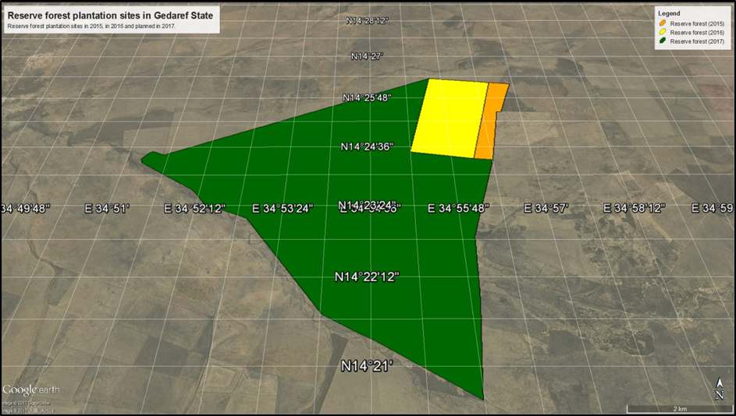
Figure 2: Reserve forest site in Gezira State
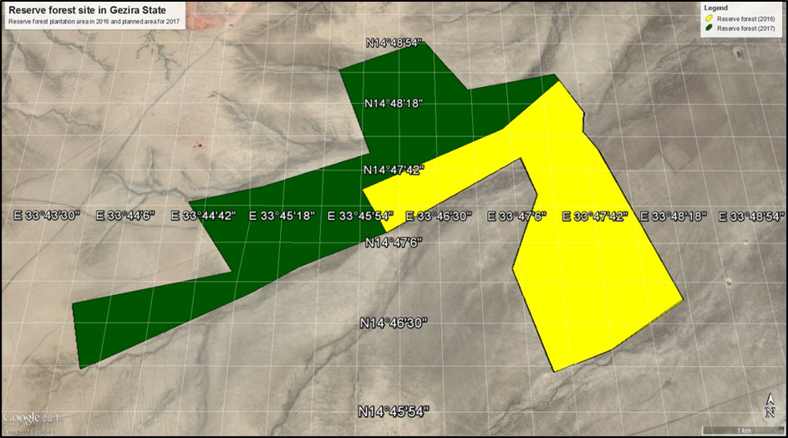
Shelter belts
In 2016 the project planted a total of 143.15 ha. The project is planning to plant additional 1166.5 ha of shelter belts in 2017. The 1,972.83 ha initially planned at the end of the project have been reduced to 1,309.65 ha.
Figure 3: Shelter belts/Mechanised farming sites in Gedaref State
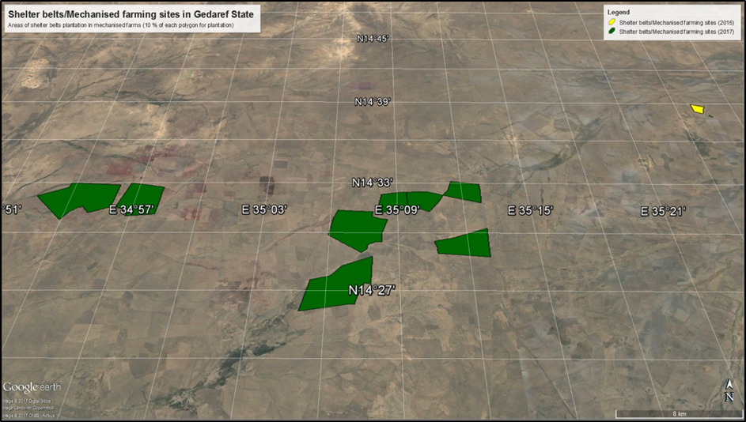

Figure 4: Shelter belts in Gezira State (1)
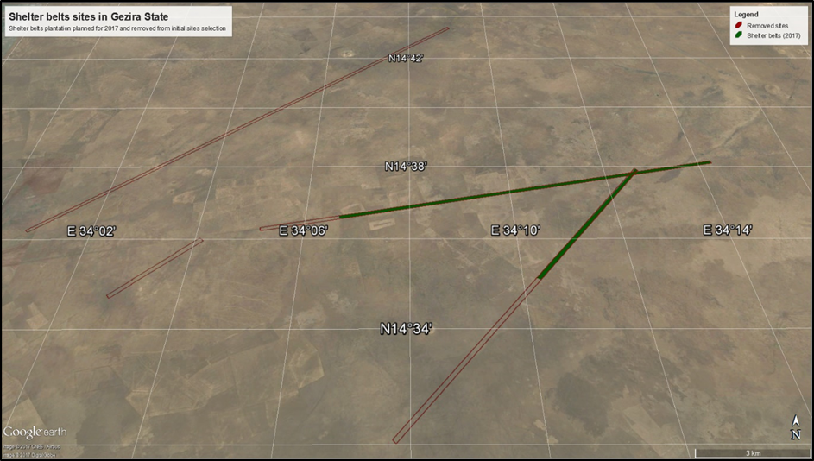
Figure 5: Shelter belts in Gezira State (2)

Figure 6: Irrigated plantation sites in Gedaref State
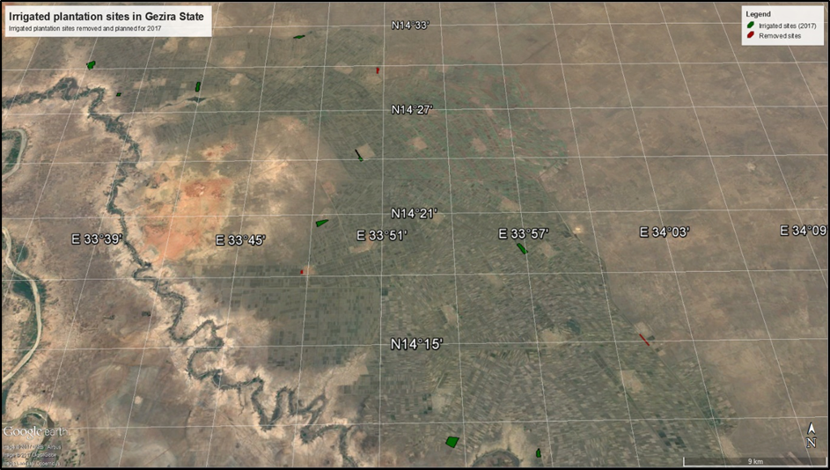
Figure 7: Irrigated plantation sites in Gezira State (1)

Figure 8: Irrigated plantation sites in Gezira State (2)
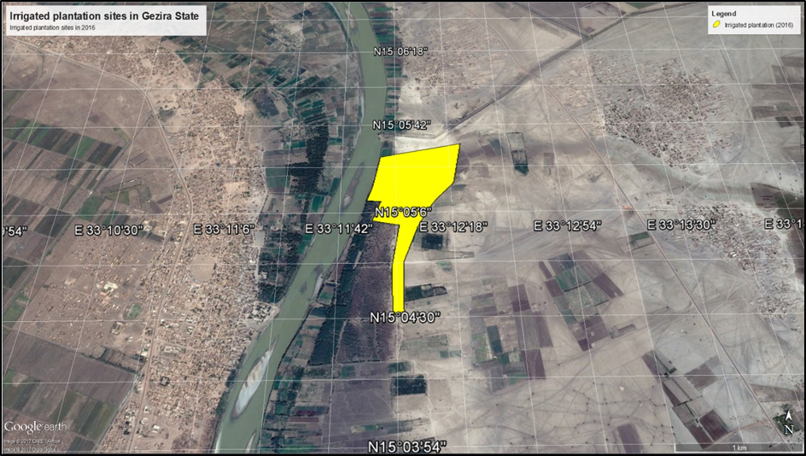
Community forest
Figure 9: Community forest plantation sites in Gezira State
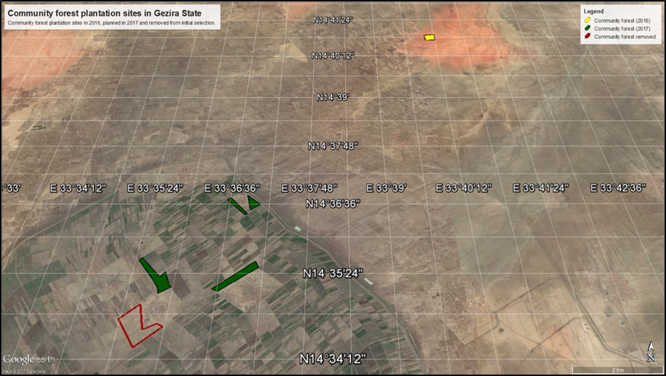

Annex 3 List of persons met
Name | Function | Location
Mr. Bakri Mahmoud Hineit | Project Manager | ICSP Khartoum
Fathi Ismail Omer Mohamed | M&E Officer/ GIS &RS Specialist | ICSP Khartoum
ABDALLA IBRAHIM ABDALLA | ICSP Financial Controller | ICSP Khartoum
Balla Musa Yassin | FNC Director Gedaref State | Gedaref State
Yousif Ahmed Abdalla | Gedaref Central Forest Circle Manager | Gedaref State
Gummah Ahmed Gummah | Implementer of A/R activities in Gedaref State | Gedaref State
Representative of Al Hasnia Community | Community of 75 families | Gedaref State
Representative of Elmukharbash Community | Community | Gedaref State
Representative of Elmukharbash Community | Community | Gedaref State
Mudathir Abdelrahman | Elsoki Elsadqab Community (300 families) | Gedaref State
Kamal Mohamed | Elsoki Elnorab Community (180 families), | Gedaref State
Ahmed Tarek | IFAD Country Director | IFAD Khartoum
Ahmed Subahi | Country Programme Officer | IFAD Khartoum
Mohamed Maki Elias | Financial Consultant | Khartoum
Mawahip Ahmed | Ministry of Finance | Khartoum
Awatif Mohamed Haroun | Ministry of Agriculture | Khartoum

Annex 4: Project Result Framework
Expected Outcomes | Expected Outputs | Activities | Indicators
1. Afforestation and reforestation (A/R) activities successfully implemented and led to increased national carbon sequestration potential | - 10,000 ha increase of reforested area in sites with less than 40% of canopy cover  - Agro-forestry initiatives involving land less farmers are implemented  - Improved water harvesting systems are defined and implemented to support successful A/R activities.  - Define suitable erosion control measures to be implemented in the A/R areas | - Define and map areas for A/R based on agreed criteria as follow:  (4 Kha) in the agriculture land based on the provision in the Forest Act (10% of rainfed agriculture schemes to be retained under forests)  (6 Kha) in the degraded forest bare land inside forest reserves  - Define and assess the baseline on the selected A/R areas based on the rules and definitions of the Kyoto Protocol  - Rehabilitation of up to four central (Showbak, Fao, Rufa’a, etc) and communal nurseries for production of seedlings of selected species for the different A/R activities  - Implement suitable, reduced tillage land preparation practices  - Implement A/R involving local communities, in the selected areas using seedlings, seeds, and enhancement of natural regeneration  - Establish a forest monitoring system and develop data for ex post estimation of carbon fluxes  - Awareness raising and technical capacity building, of the targeted farmers  - Define suitable models for agroforestry in irrigated area in collaboration with landless farmers, based on successful national and regional experiences and practices  - Prepare implementation agreements with farmers based on existing experiences and taking into consideration the objective of carbon sequestration and climate change mitigation  - Screen, assess and select suitable water harvesting techniques from the experiences available in the Butana area or in other similar areas in other parts of Sudan  - Develop site-specific contour maps for the selected A/R areas  - Implement the selected water harvesting systems or techniques in the A/R areas and assess their effectiveness in supporting improved A/R activities  1.4.1 Study on erosion control | - # of ha of afforestation in sites with less than 40% canopy cover  - # of communities/house -holds participating in increasing national carbon sequestration potential through A/R  - Baseline on A/R assessed  - # of ha. Invested in afforestation in sites with less than 40% of canopy cover  - Volume of increment carbon uptake  - Nurseries established 1.1.d) Monitoring system in place  - .a) # of land less communities involved in agro-forestry activities 1.2.b) Area under agroforestry  - a) Area with water harvesting systems (ha)  1.3b) # of hafirs (reservoirs) and wells dug  - c) # of water harvesting micro- catchments constructed  - a) Study completed  1.4b) # and area of control measures implemented
Expected Outcomes | Expected Outputs | Activities | Indicators
2. Forest carbon stock is maintained in the long run, through conservation and improved management including protection from causes of deforestation and fires | 2.1 Participatory forest management promoted as a way to protect the carbon stock from drivers of deforestation (illegal felling, over grazing, poor management, etc.) | 2.1.1. Define geographical boundary encompassing one or more adjacent forest reserves and the A/R areas in Gedaref or Gezeera States  - Assess the forest biomass carbon stock and deforestation rates suing remote sensing technology and ground surveying  - Identify and assess all factors causing deforestation and forest degradation  - Prepare and implement forest management plans using participatory approaches with the objective of reducing deforestation and forest degradation, while addressing local needs and other causes of deforestation  - Increase forest reserves area and potential for carbon sequestration  - Design and execute fire management plans in the A/R areas and as part of the forest management plans that contain fire lines network  - Prepare and implement post-fire management plans using participatory approaches  - Revise forest policies and legislation to enhance participatory forest protection and management  - Strengthen and raise institutional and community capacities in the use of remote sensing technology for monitoring and controlling fire risks  - Monitor and prevent deforestation and forest degradation in Butana  - define properties to be ensured and estimate their values, define perils covered and excluded, time duration, and premium payment  - prepare at least two insurance contracts for (1) irrigated forestry, including agroforestry, home gardens and community nursery, and (2) rain fed dry land forestry (part of 2.4.3)  - special study on micro insurance | - carbon stock\ tons\ha  - # of stakeholders involved in maintaining forest carbon stock in the long run.  2.1a) # of community forests registered and managed by local communities in a participatory manner  2.1b) # of community and home nurseries established  - c) # of seedlings produced  - a) Fire Risk Management Plan elaborated  - b) # of fire lines opened 2.2c) # of fire brigades  - a) increase in carbon stock by X tons per year  - .b) Area of forest reserves increased by X%  - a) # of communities enrolled in forest micro-insurance.  2.4b) # of micro ensured forests.
 | 2.2 Fire management system is improved and post-fire management plans are developed and implemented
 | 2.3 Long-term sustainability of biomass carbon storage potential increased
 | 2.4 Forest Micro-insurance schemes tested on a pilot base in two sites
3. Wide diffusion of highly efficient, biomass energy technologies, as appropriate, is promoted in the project area using climate-friendly incentives. | 3.1 GHG emissions from biomass energy production at the community level reduced | - Assess household and total consumption and/or demand for biomass energy of the targeted communities  - Identify barriers and enabling factors for energy technology, .e.g. suitable applications, know-how and the differences in local circumstances of targeted communities  - Address any potential barriers for dissemination and use a combination of revolving input and climate- friendly incentive systems .e.g. successful household | 3a). use of LPG in 6,000 households 3.b) use of improved wood stoves in 7,000 households  3.2a) # of improved and modern climate friendly stoves used in the project area (6,000 LPG).  3.2.b) # of households using improved wood stoves (7,000)
 | 3.2 The use of improved and modern climate friendly stoves using alternative energy sources is promoted to replace inefficient wood stoves | tree planting to promote wide dissemination  - Build technical capacity of the targeted groups in construction and use of improved stoves  - Distribute improved stoves to households and install suitable applications in local institutions  - Establish monitoring system to ensure successful diffusion and use of the energy technologies and for assessment of associated emissions reductions  - Identify barriers and enabling factors for LPG technology, e.g. suitable applications, availability of services, know-how and the differences in local circumstances of targeted communities  - Build technical capacity of local people to use LPG cooking facilities and address any potential barriers for dissemination of LPG technology such as refilling and service stations  - Prepare and disseminate appropriate standard safety measures to enhance the safe use of LPG in the target areas  - Define and use incentives that encourage tree planting and forest conservation to disseminate LPG cooking facilities. Use FNC experience in this area  - Based on BIRD experience, develop and implement a system to use the project resources allocated for the dissemination of LPG cooking facilities as revolving input
4. Institutional and technical capacities for monitoring forest carbon stock and associated GHG fluxes are developed at the national level and awareness is raised at the local level about the role of forest and biomass carbon stock in climate change mitigation | - Enhancing national capacity to develop implement and monitor potential LULUCF projects including CDM, REDD or voluntary mechanisms  - Enhancing local capacity to promote forestry awareness among the target group, and to | - Training sessions for policy makers and technicians;  - Analysis and processing of relevant time series data for monitoring land use change and carbon fluxes and stocks.  - Test at the local level state of the art GIS for LULUCF monitoring and up scale the outcomes at the national level;  - conduct specific studies to generate local data and parameters for better estimation of carbon stock change and GHG fluxes  - establishment of a baseline and monitoring system for deforestation and forest degradation  - Training sessions for policy makers and technicians;  - Plan and execute 20 training sessions for 120 | 4.a) Monitoring system for measurement of carbon stock and associated carbon fluxes in place and fully operational, including baseline.  4.1a) # of baseline surveys and data collected on deforestation and forest degradation  4.1b) # of analyzed and processed relevant time series data for monitoring land use change and carbon fluxes and stocks;  4.1c) # of technicians trained in GIS 4.1.d# of training and awareness raising events  4.1e) # of studies to generate data for  better estimation of carbon stock changes and fluxes
 | develop, implement and monitor potential LULUCF projects | technicians  - Organise awareness-raising campaigns at local community level  - Training for development of non-wood forest products-based traditional and intermediate technology to process non-wood forest products in cottage industry or use of these products (fruits, seeds, honey) for sales, and establish pilot projects. | 4.1f) # of MRV models established for carbon stock change and fluxes  - g) GIS tested for LULUCF monitoring  - a) #. of training sessions in awareness raising campaigns for communities and policy makers  4.2b) # of participants in training and awareness events  4.2c) # of pilot projects on non-wood  forest products
5. Project Management | 5.1 FNC and BIRDP implement programmes and financial management systems to ensure effective implementation | - Establish Project management structures including techniques, procedures, people, and systems that lead to effective implementation of the project.  - Disseminate lessons learned thereby assuring regional coverage  - Establish a dedicated project website and a database on climate change related issues and activities | - Project implementation on schedule  - website accessible

Annex 5 Exit strategy plan, ICSP -30th July 2019
ICSP stakeholders and partners
Ministry of Agriculture State Level (MoAS)

Youth Groups (YGs)
Village Development Committee (VDC)
Extension Units at state level (EUS)
Forests National Corporation State Level
Non-Governmental Organizations (NGOs)
Rahad Agriculture Project
Government Administration
ns

Forests National Corporation (FNC)
Local Extension Workers (LEWS)
Ministry of Agriculture and Forests (MoAF)
Butana Development Fund (BDF)

Federal Government
Ministry of Finance and National Economy (MoFNE)
REDD+ Sudan

Youth
Plan of Actions

NO | Component | Activity | Key players& their roles to play |  | Recommendation for sustainability | Budget (for three years (SDG) | Plan of actions
NO | Component | Activity | Player | Role | Recommendation for sustainability | Budget (for three years (SDG) | Plan of actions
1 | 1 | A/R inter-vention inside reserved forests | FNC | Prepare and implement PMP for the A/R sites within reserved forest | - To ensure the availability of vehicles and motorbikes in the A/R sites for at least three years to enable the germinated seedling to sustain  - To be sure that FNC will secure the technical staff and forests guards to follow up the sustainability of project activities by implementing the PFMP prepared by ICSPS | 1,324,000 | - Operation cost for Four Vehicles and six motorbikes  - Incentives to forests guards  - Enforcement of the forests law to enhance forests protection
1 | 1 | A/R inter-vention inside reserved forests | MoA at States level | Liaisons between FNC and Mechanized farmers | - Continue in providing Technical and financial support  - seeks for donors fund | 1,324,000 | - Enforcement of natural resources policies & legislation
1 | 1 | A/R inter-vention inside reserved forests | Mechanized Farmers | Keep their investment out of reserved forests and establishing shelterbelts | - Play role in protection the plantation and stop encroaching in reserved forests | 1,324,000 | - Create win- win partnership between farmers and FNC for adopting participatory management of forests
1 | 1 | A/R inter-vention inside reserved forests | Local communities | Participate in protection of the planted sites | - Ensure that local communities received the needed technical and financial support | 1,324,000 | - Adopt agroforestry system  - Establish MoU between FNC & local communities for PFMP
1 | 1 | A/R inter-vention inside reserved forests | NGOs | Give support and conduct awareness raising to local communities to enhance forest protection | - To create partnerships and interlinkage between FNC and related organization such as FAO to benefits from ICSPS outcomes | 1,324,000 | - Conducted Extensions program  - Encouraging scaling up best practices
2 | 1 | A/R inter-vention in shelterbelt | FNC | Continue in implementing 10% of shelterbelt | - Legalization the status of Shelterbelts | 165,000 | - Protection of shelter belt for at least 3 years
2 | 1 | A/R inter-vention in shelterbelt | MoA at State level | Liaisons between FNC and Mechanized farmers | - Legalization the status of shelterbelts |  | - Integrated shelter belts management plan with CNRGS  - Organize exchange visit among farmers to modeled shelterbelts
2 | 1 | A/R inter-vention in shelterbelt | Shelterbelt Authority | Continue in protection and establishing shelterbelt | - Include the area of shelterbelt in the overall management plan of SA |  | - Enforcement of shelterbelts law to enhance protection
2 | 1 | A/R inter-vention in shelterbelt | Mechanized Farmers | Secure land for 10% shelterbelt | - Commitment in establishing and protection of shelterbelt |  | - Engage Farmers in agroforestry activities  - Investing in NWFP
2 | 1 | A/R inter-vention in shelterbelt | BDF | Liaisons among MOA, FNC, Donors and Mechanized farmers | - Fund raising  - Coordination among deferent players
2 | 1 | A/R inter-vention in shelterbelt | NGOs | Give support and conduct awareness raising to farmers to enhance protection of the planted areas | - Continue in providing technical support and incentives to farmers |  | - Work with Afforestation society and youth groups to support farmers in plantation and protection
3 | 1 | Community forests | FNC | Establishing CFs through coordination with MOA | - Ensure that technical and financial support is there |  | - Registrations of CFs  - Develop SFMP for CFs
3 | 1 | Community forests | MoA at States level | Liaisons between FNC and local communities | - Legalization the status of communities forests |  | - Continuously
3 | 1 | Community forests | Local Com. | Protection of CFs | - Ensure that local communities received the needed technical and financial supports |  | - Held awareness raising campaign and exchange visits
3 | 1 | Community forests | NGOs | Give support and conduct awareness raising to local communities to enhance protection of the planted areas | - Continue in providing technical support and incentives to local communities |  | - Work with Afforestation society and youth groups to support communities in plantation and protection
4 | 1 | A/R inter-  vention in irrigated sites | FNC | Provide technical and financial support in implementing 5% of irrigated projects to be forested areas | - Legalizing the status of irrigated forests  - Continue in implementing forests extensions programs |  | - Encourage the adoption of implementation of 5% of irrigated schemes as forest through agroforestry initiative  - Secure seeds and seedling  - Update the MoU between FNC and Rahad project as needed
4 | 1 | A/R inter-  vention in irrigated sites | MoA at State level | Liaisons between FNC and farmers | - Secure fund  - Ensure the availability of 5% of irrigated projects for A/R activities |  | - Encourage the adoption of implementation of 5% of irrigated schemes as forest through agroforestry initiative  - Secure seeds and seedling
4 | 1 | A/R inter-  vention in irrigated sites | Rahad A. Scheme | Protection of planted sites and complete the rest of 5% of the project area as forest | - Secure funds for land preparation and planting  - Coordinate with FNC in securing seeds and seedlings |  | - Complete all the area targeted as shelterbelt 5% within three years
4 | 1 | A/R inter-  vention in irrigated sites | Local communities & farmers | Participate in plantation through agroforestry initiatives | - Continue in providing technical and financial support to local community to actively participate in A/R activities |  | - Engage actively in protection and plantation through agroforestry
4 | 1 | A/R inter-  vention in irrigated sites | NGOs | Give support and conduct awareness raising to local communities to enhance protection of planted sites | - Create partnerships and interlinkage between FNC and related organization such as FAO for fund raising |  | - Work with Afforestation society and youth groups to support communities and farmers in plantation and protection
1 | 2 | Increased Carbon Stock tons \ ha beyond the project area | FNC | Protection of the planted areas from the drivers of deforestation | - Strictly implement the PFMP |  | - Develop partnership MoU between FNC and local communities  - Access to Carbon trade finance Mechanism
1 | 2 | Increased Carbon Stock tons \ ha beyond the project area | MoA at State level | Ensure the implementations of the 10% in rain fed Agri. project as forests | - Securing the funds and technical support |  | - Set programs for A/R activities
1 | 2 | Increased Carbon Stock tons \ ha beyond the project area | Shelterbelt Authority | Protection of the shelterbelt and complete the 10% | - Securing the funds  - Organize farmers to be fully engaged in the implementation of A/R activities |  | - Compete establishing shelter belt in the area around Elmukharbash forest within three years
1 | 2 | Increased Carbon Stock tons \ ha beyond the project area | Mechanized Farmers | Implement the 10% as shelterbelts in their agriculture projects | - Full commitment in protection of the invested sites |  | - Participate in agroforestry activities
1 | 2 | Increased Carbon Stock tons \ ha beyond the project area | BDF | Fund raising | - Have similar activities the other working projects within Butana area
1 | 2 | Increased Carbon Stock tons \ ha beyond the project area | Local com. | Participate in protection and agroforestry activities | - Training and capacity building continue |  | - Work with VDC and youth group to enhance protection of forests area
1 | 2 | Increased Carbon Stock tons \ ha beyond the project area | NGOs | Provide capacity building training | - Work with government and donors for seeking funds
2 | 2 | Maintaining forest carbon stock in the long run | FNC | Develop and implement SFMPs | - Ensure the implementations of the plans with full engagements of local communities |  | - Strictly Implement the PFMP according to the plantation schedule  - Respect the MoU between FNC and local communities
2 | 2 | Maintaining forest carbon stock in the long run | MoA at State level | Liaisons among deferent plyers | - Provide funds and technical support |  | - Work with FNC in developing social fencing mechanism
2 | 2 | Maintaining forest carbon stock in the long run | Shelterbelt Authority | Protection of shelterbelt | - Continue in protection and planting new areas
2 | 2 | Maintaining forest carbon stock in the long run | Mechanized Farmers | Maintaining and protect the forested sites | - Keeps the commitments of maintaining forested areas
2 | 2 | Maintaining forest carbon stock in the long run | BDF | Coordination’s and seeks of Fund | - Initiate similar programs |  | - To come up with mechanism of coordination committee to unify efforts and develop an action plan / vision to ensure sustainability
2 | 2 | Maintaining forest carbon stock in the long run | Local communities | Protections of the forested sites | - Engage communities in forest protection by means of social fencing |  | Conduct meeting/ workshop that bring VDC in each community with relevant government department to develop and review action plans
2 | 2 | Maintaining forest carbon stock in the long run | NGOs | Conduct awareness raising campaign | - Work with youth groups and women in protection program
1 | 3 | Diffusion of highly efficient, biomass energy technologies, as appropriate, is promoted in the project area | FNC | Give technical and financial support to local communities | - Monitor the smooth functionality of revolving fund  - Fund raising |  | - Purchasing and deploying of new units to new communities within project area  - Monitoring the mechanism of revolving funds
1 | 3 |  | MoA at State level | Coordinate between players | - Funds raising  - Capacity building and training to local communities |  | - Purchasing and deploying of new units to new communities within project area  - Monitoring the mechanism of revolving funds
1 | 3 |  | BDF | Continue deployments through other projects | - Funds raising
1 | 3 |  | Local com. | Continue in using clean sources of Energy | - Keeps revolving fund mechanism functioning
1 | 3 |  | NGOs | Provide capacity building training | - Engage deferent stakeholders |  | - Work through youth group in deployment and refilling
2 | 3 | Assessment on the deployments of Alternative energy in the project area | FNC | Conduct studies | - Implement the findings of the studies |  | - Secure technical support for the assessment  - Implement the recommendation of the assessment
2 | 3 |  | MoA at State level | Conduct studies | - Follow up and coordinate the implementations of the recommendation with related partners |  | - Implement the recommendation of the assessment
2 | 3 |  | BDF | Participate in the assessment study | - Follow up the implementations of the recommendation with related partners
2 | 3 |  | Local communities | Participate in assessment | - Implement the recommendations |  | - Participate actively in the assessment
1 | 4 | The finding of the REDD+ RL/REL and MRV for the natural forests eco system in Central Sudan (Berega forest). | FNC | Coordinate between deferent partners e.g. REDD+ to insure full integration of the result of the studies | - Conducted similar studies in other Regions
1 | 4 |  | REDD+ Sudan | Integrated the result of RL/REL and MRV system for the REDD+ forest in the national MRV system. | - To ensure that there is full coordination with the REDD+ -Sudan program and IFAD other programs and BDF to scale up the results of the base line and REDD+ studies |  | - Main streaming the finding of the study in the national REDD+ strategy
1 | 4 |  | FM. of Agri. & Forests | Coordinate among deferent players | - Fund raising
1 | 4 |  | HCENR | Integrated the result of RL/REL and MRV system for the REDD+ forest in the national MRV system and in NCRs | - Give the Technical support in the capacity building

As communicated to the GEF, through PIR 2017, IFAD reviewed the co-financing for this project, following a decision by the Government to implement ICSP independently from the IFAD BIRDP project. IFAD’s SECAP Note (Social, Environmental and Climate Assessment Procedures), drafted jointly for BIRDP and ICSP in 2016, was applied through both projects.
NFC, ICSP. September 2019. Establishment of Biomass Carbon Baseline and Development REDD+ Reference”.
It should be noted that this number consolidates figures from different activities. The project M&E system did not feature identification of final beneficiaries with a unique identifier (such as the national ID number), which is now common in IFAD projects. So there is a moderate risk that the total may include some double-counting (i.e. beneficiaries having availed different services of the project being counted twice).
Source: BIRDP ecological zonation study, 2012.
Sudan's Second National Communication under the United Nations Framework Convention on Climate Change, January 2013
NFC, ICSP. September 2019. Establishment of Biomass Carbon Baseline and Development REDD+ Reference”.
Republic of Sudan, 2015. Intended Nationally Determined Contributions (INDCs) of the Republic of Sudan
FNC, September 2019. Establishment of Biomass Carbon Baseline and Development of REDD+ Reference
Salah, Y., M. 2018. The General Directorate for Forests Sustainable Development / The Technical Administration. Report on Forests equipment under the Project UTF/SUD/079/SUD. Khartoum - FNC, April 2018. 2p
The recommended types and number of efficient energy units for each village was based on the number of HH in each income group. Distribution of solar lanterns, on the other hand was recommended for HH who had no electricity connections. Distribution has been done with the same revolving fund system adopted by BIRDP. Each HH women paid monthly installment for all received efficient units, as determined by ICSP staff and women development organization members in the village.
ICSP, 2019. El Mukharbash Forest Participatory Management Plan 2020-2035
IFAD. 30 June 2019. Project Implementation Report, GEF projects grants
Jonah Busch et al, May 2019, Potential for low-cost carbon dioxide removal through tropical reforestation, in Nature Climate Change. (https://www.nature.com/articles/s41558-019-0485-x )
NFC. September 2019. Draft Final Report, IPSC, Developing Baseline for the afforestation & Reforestation (A/R) in the project area: Gedaref and Gazira States.
MTR, June 2017.
Mid Term Review Mission, June 2017
Butana Integrated Rural Development Project (BIRDP) Loan 717-SD. Proposal for Additional Financing August 2016. Appendix 3
Guidelines for GEF Agencies in Conducting Terminal Evaluation for Full-sized Projects. Approved by the GEF IEO Director on 11th of April 2017.
Butana Integrated Rural Development Project (BIRDP) Loan 717-SD, Proposal for Additional Financing, August 2016
Updated by M&E officer as per end of August 2019
Estimated budget for consolidation concerning a period of three years (Oct. 2019 – Oct. 2022).
This budget includes operational budget only
Each state coordination unit to get full ownership of all assets e.g. vehicles tractors
Reference made to People Afforestation society and other active afforestation groups; NGOs also when mention else were refer to other societies such as Environmentalist Society, Sudanese Society for Environmental protection and other youth groups

